To start your Micro:Bit project, go to makecode.microbit.org
Click on New Project
Step One:
- Before we can start coding lights onto our MicroBit, a new package needs to be added with the Neopixel blocks of code.
To do this, click on Advanced and choose Extensions



Once in Extensions, choose the Neopixel package. You may need to search for this

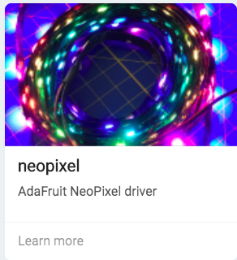

2. Open the Neopixel menu and move this block into the On Start block

Change the number of pixels to the number you will be attaching to your Micro:Bit. I am going to use 10 in this example.

My code now looks like this:

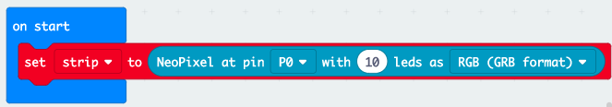

The P0 is the pin that I am attaching my LEDs to. If you need to change this, do it now.
You will see on the left hand side that the LED’s have appeared under the Micro:Bit. You will be able to test your code here.

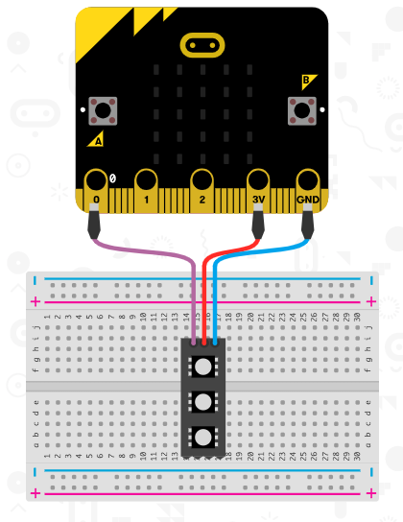

3. To change the brightness of the LEDs, go to the Neopixel menu and click more
Drag the set brightness block inside the Start block and change the number to 50.



We change the brightness so that the lights don’t get burnt out and to protect our eyes when looking at the bright light.

Step Two:
1. To start adding color to our Micro:Bits we are going to program the A button first. To find this, go to the Inputs menu and take out an On Button A Pressed block. This can go anywhere on your workspace.

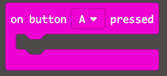

2. To go inside this block, find the strip show color block from the Neopixel menu



3. Push button A on the Micro:Bit on the left of the screen and your LEDs should now light up red. They will stay on at the moment until you turn the Micro:Bit off.

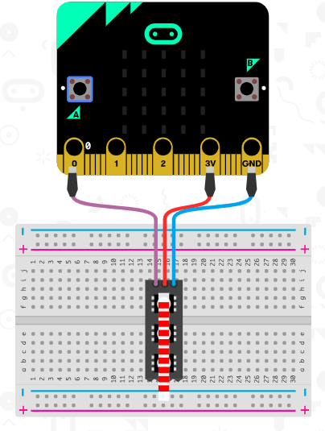

Step Three:
1. To make the lights turn off after a certain period of time, we need to put a pause in after the lights turn on. The Pause is found in the Basic menu

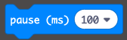
The pause is in milliseconds so 1000 = 1 second. I am going to change this number to 5000 so that my lights stay on for 5 seconds.

2. Next we need to add the following blocks from the Neopixel Menu

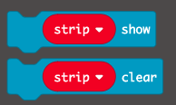

We use the clear block to clear the pattern on the LEDs and the show block to show the changes.
Make sure the Clear block goes first

Your code should now look like this:

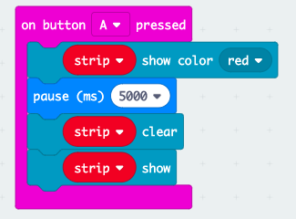

Step Three:
1. To make your LEDs show a rainbow pattern that moves around we need another input block. I am going to use the on button B pressed

Now instead of the Show Color block, we want to use the Show Rainbow block from the Neopixel menu.
Put this code into your input so that the code looks like this:

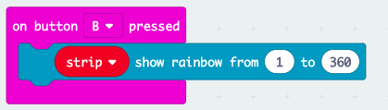

If you click button B now, the rainbow is shown but it just stays on the screen.

2. To make the rainbow move, we need to think about how many times we want it to scroll around and how quickly.

You can find the Repeat block in the Loops menu and it looks like this:

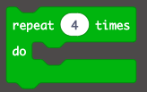

Put this block underneath the Neopixel block. The next few lines of code will go inside this block. Change the number of repeats to 50

3. Back in the Neopixel menu, choose the block Rotate Pixels by 1 and the Show block. Add them both inside the loop



Next we want to add a pause so that the pixels wait a short period of time before changing position.
For this, you will need another Pause block from the Basic menu.

The code should now look like this:

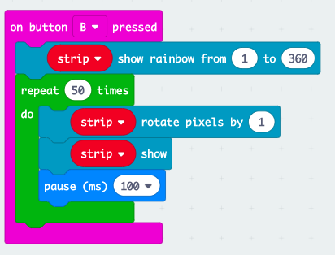

Test out your code and see what happens.

4. You will have noticed that as your program finishes to run the lights stop moving but are still on the screen. We clear them the same way as before using these two blocks.

Step Four:
1. Now we need to add an image or pattern to the Micro:Bit. To do this we go back to the Basic menu and choose the Show Icon block.

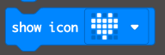

Place this block directly under the input block. I’m going to start with the Button B.

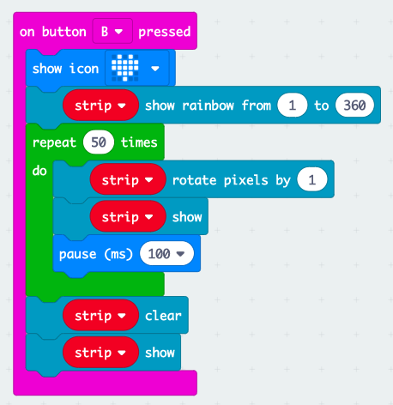

Click on the arrow next to the heart to change the picture shown

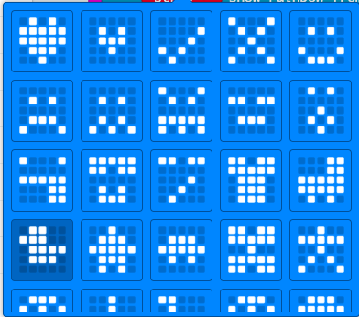

2. Once you’ve chosen the image you want (I chose the duck) we need to clear it when our programme stops running same as we did for the lights.

Back in the Basic menu, click more to open up more options and choose Clear Screen.

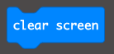

Place this block at the very end of your code so that the image goes away at the same time as the lights stop flashing.

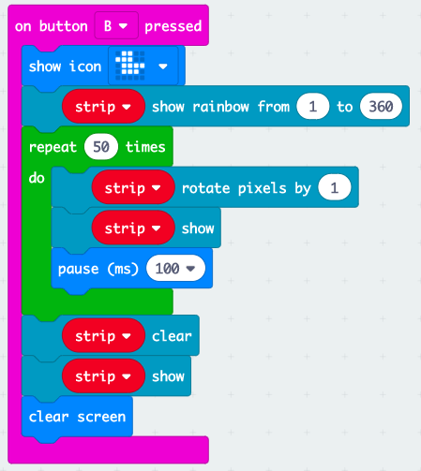

3. For Button A, I’m going to use a different icon block. From the Basic menu choose the Show LEDs block which looks like this

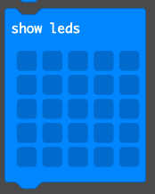

Place this block underneath the Button A input same as we did for Button B.

Create your own pattern by clicking on the squares that you want to light up. I have drawn a happy face.

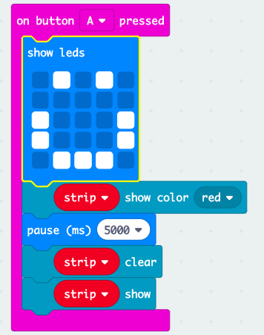

4. Finish the code by adding in the clear screen block and test out the code on the Micro:Bit.

You are now ready to upload your code onto your Micro:Bit!

Note: If the code doesn’t work, look back through the steps to find any bugs

