To start your Micro:Bit project, go to makecode.microbit.org
Click on New Project

- For this game we won’t be needing the Start or Forever blocks so we’ll start by moving them out the way.

Click on the Input menu and select the block called Shake


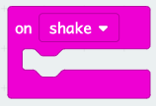

2. Next go to Variable and create a new variable called Dreidle


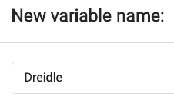

Drag out a set Dreidle to 0 block and place it inside the input.

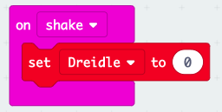

3. In Math find a Pick Random block and place it inside the variable. Change the numbers to 1 - 4 as the dreidle has 4 sides.


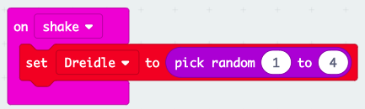

4. Next we need to tell our micro:bit what to show depending on the variable number. To do this, find the If - Else block from Logic and place it under your variable block in the shake input.


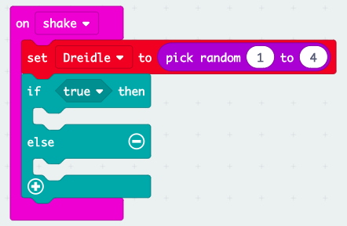

Click on the plus at the bottom of the block twice to add two more sections. The block should now look like this:

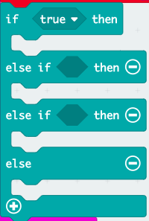

5. Now we need to let the micro:bit know what to do for each number (1 - 4).
From Logic take out 3 = blocks and place them in the top three sections of your if block. The bottom section doesn’t need one before if the variable Dreidle doesn’t equal 1, 2 or 3 then it has to be 4.

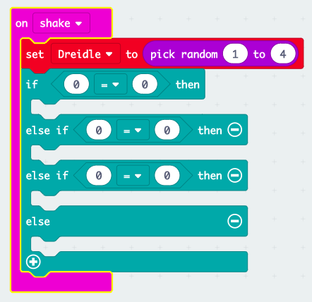

Number each of the = blocks 1, 2 and 3

From Variable drag out 3 Dreidle blocks and put them in place of the 0 in the conditional (if block).


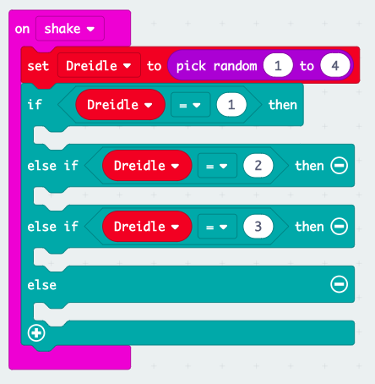

6. From Basic drag out a Show LED block and place this into the first if. On this block draw a letter from the dreidle.


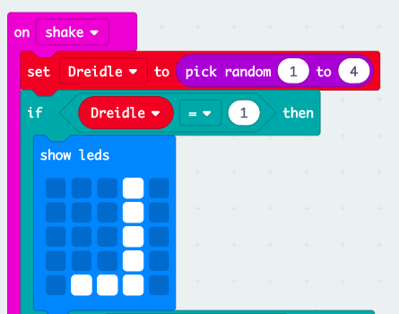

Repeat this step so that each section has a letter of the dreidle.

Test your code by clicking on the ‘Shake’ on the micro:bit emulator on the side and then download the program onto the micro:bit.

