Student Workbook 1
- Where is my car traveling to? Mark the right square with an X

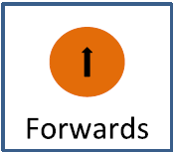
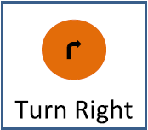
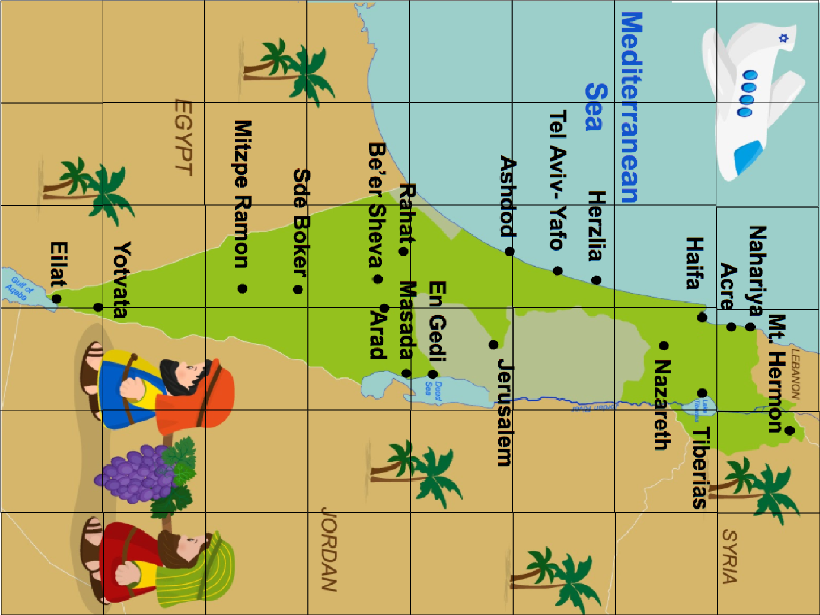

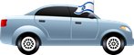

- Can you get my car to Mt Hermon (the X)? What is the fastest way to get there?

- Can you get my car from Mt Hermon to Masada?

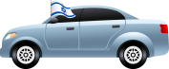

- Can you get my car from Ashdod to Eilat?

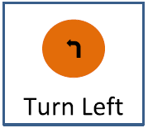

- Can you get my car from Tiberias to Be’er Sheva?

- Can you get my car from Nahariya to Ashdod?

EXTENSION

- How would you get from Sde Boker to Herzlia?

L

F

