To start your Micro:Bit project, go to makecode.microbit.org
Click on New Project
In this project we will be showing the life cycle of a tree. Make the tree grow by pushing button A and show what happens at the end of the lifecycle by pushing button B

Step One:
- For this challenge we won’t be needing the Start or Forever blocks so we’ll start by moving them out the way.

Click on the Input menu and select two of blocks that say Button A Pressed

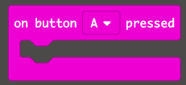

On one of the Button A Pressed blocks, click on the arrow and change it to Button B

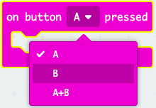

2. Next, go to the Basic menu and choose this block. Drag it into the on Button A Pressed block

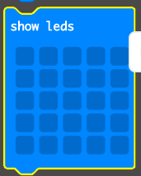

Click on the squares to turn on the lights on the Micro:Bit

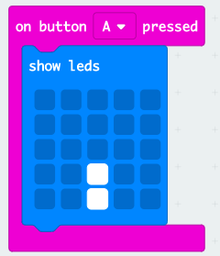

Go back to the basic menu and choose another one of these blocks to go underneath. Draw the next section of your tree in this block.

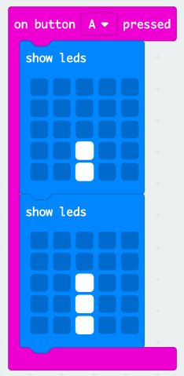

Continue to use these blocks to build up your tree.

3. Now that you’ve built up your tree on Button A, can you code Button B to show the end of the tree’s life cycle?

Start with the full tree and slowly show the tree losing its leaves and getting smaller.

Extension:
Can you add another Input called Shake and code this so that the leaves fall off when you shake the tree?

