This booklet will go through how to sew and connect LEDs together as well as to the battery pack.
Step One:
- LED stands for Light Emitting Diode. For this activity we are using a single-color LED meaning that we don’t need to add any code for it to work.

The LED will have two holes which we will use to sew these are + (positive) and
- (negative)

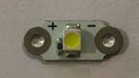

2. When sewing LEDs, make sure that the positives and negative sides line up.

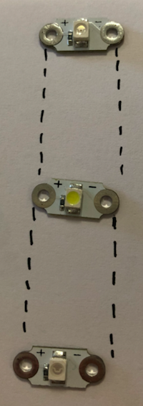
NOTE: It is very important when sewing or connecting your LEDs that the positive and negative sides don’t touch each other

If the sides are touching, the circuit will not work.

The positive and negative sides light up like this:

When you start sewing, use one long piece of thread for each of the two sides. One piece of thread to connect the positive side and a different piece of thread to connect the negative side.

3. When sewing around each LED, make sure you loop the thread through each hole at least three times as shown here:

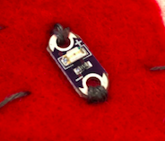

Loop the thread through the hole and then move to the next LED. Keep your stitches close together and make sure that they are pulled through tight to avoid problems when you put the battery in.

