Scratch Jr – Modeh Ani
Open Scratch Jr on your iPads


- To delete the cat, tap and hold on to him until the red X appears.
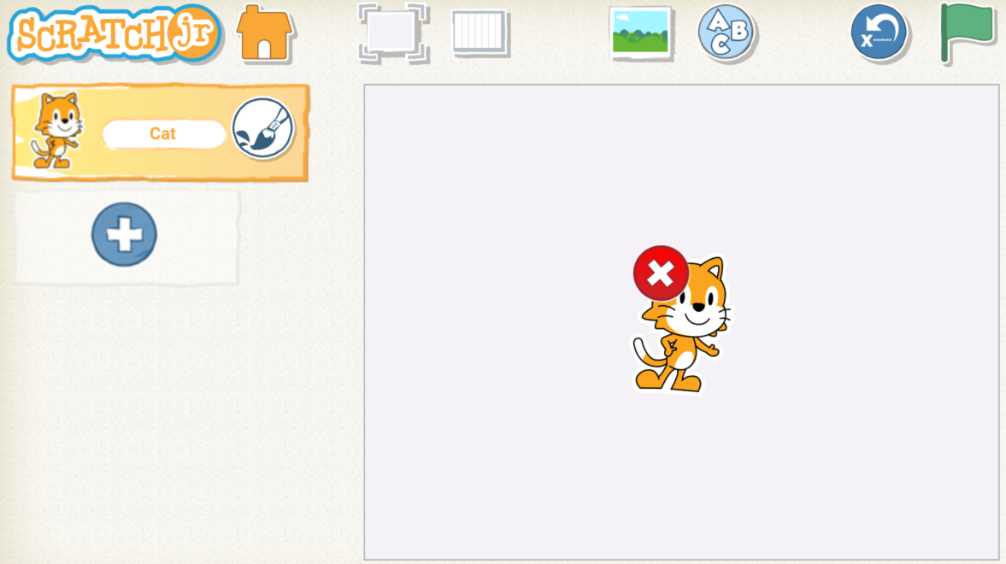

- Now we need a new Sprite that will be you in your animation.

Click on the plus where the cat was to choose your Sprite.

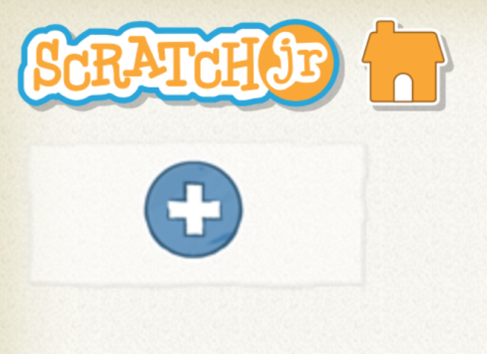

Choose a boy or a girl that looks like you.

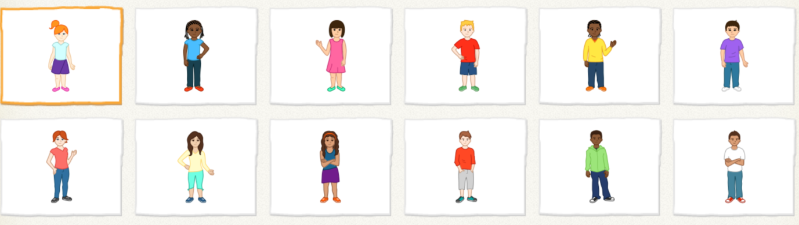

Click the tick once you’ve chosen



- You can now paint your Sprite different colors by clicking on the paintbrush next to the picture

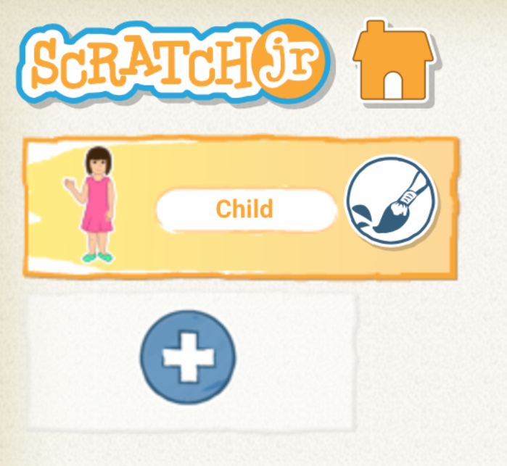

Paint and change your Sprite and click the tick when you’re done.

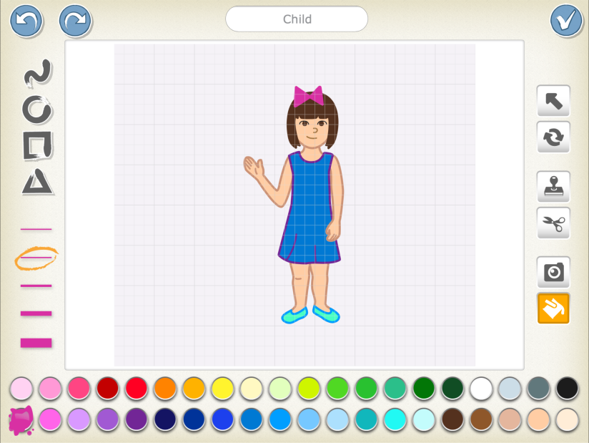

- We are now ready to code your Modeh Ani!

To start doing this, we need to first introduce ourselves. In the yellow menu choose the green flag.
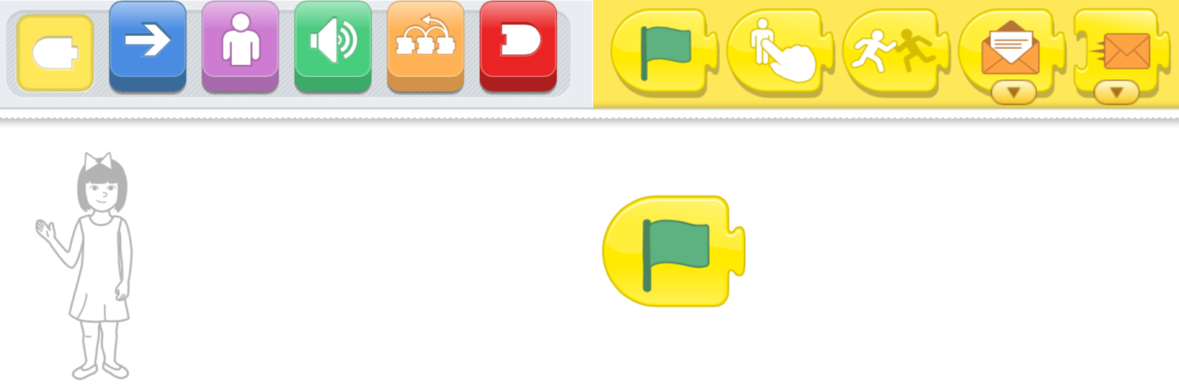

Next we need the purple menu. Find this block and click it next to the green flag.
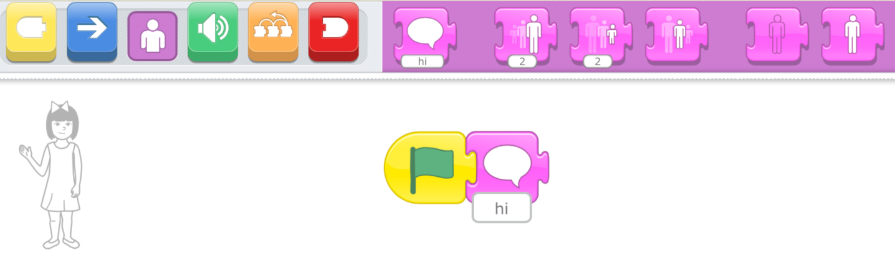


Click on and see what happens:

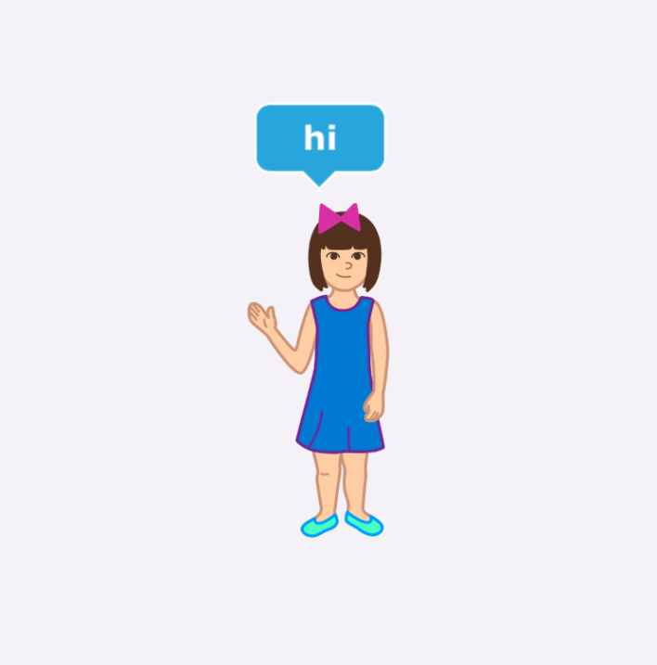

- We want to say a little more so lets put in one more purple block.

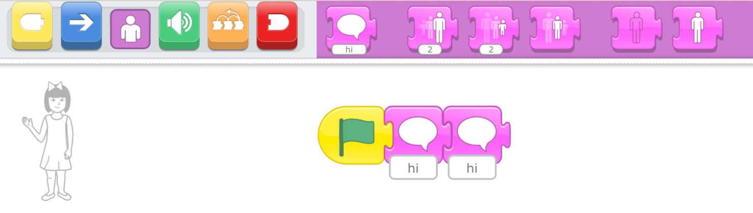

Click on the writing and write in your name.

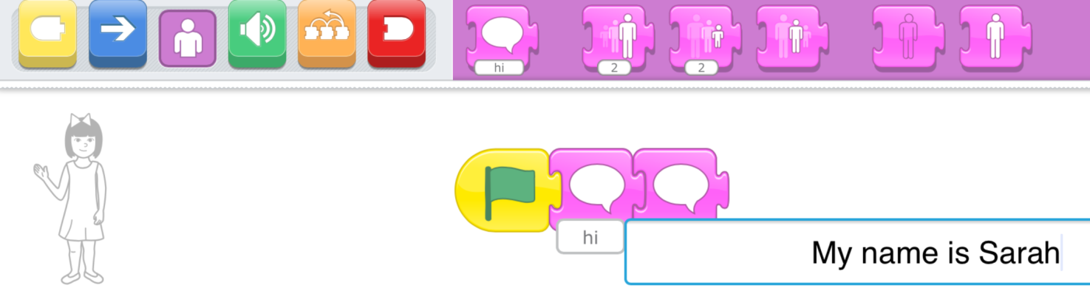

Now what happens when you click the

- We are now going to add new pictures of different things that we are thankful for. To do this, we need to add a new Sprite.

Click the + under the picture of you to choose a new picture.

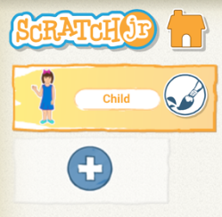

I am going to choose the sun as my next picture but you can choose anything you like! Once you’ve chosen click the tick.
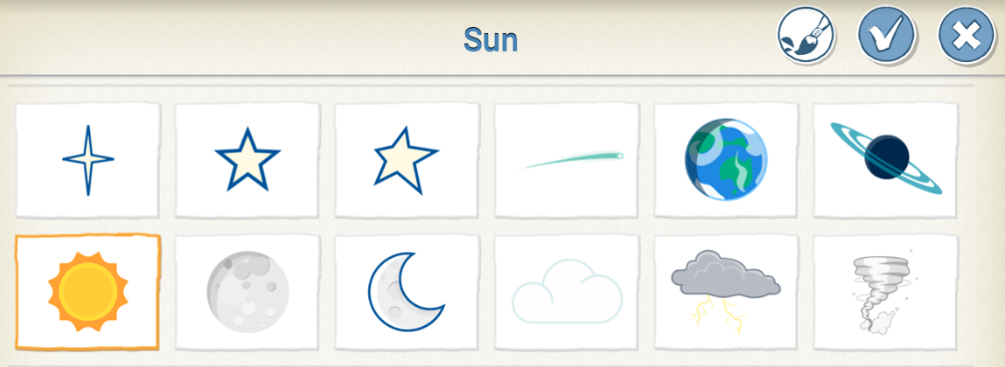

Move your Sprite to where you want it on the screen.
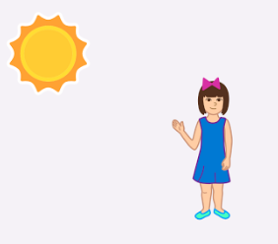

- We are going to choose a new yellow block this time. This block means that our sun will do something when it is touched.

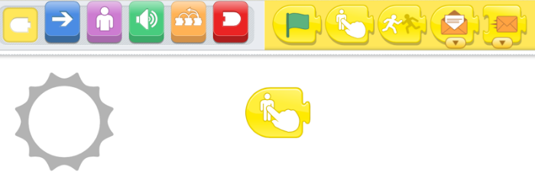

Now use the same purple block that we used on our picture

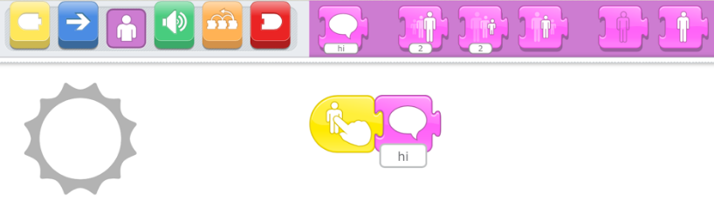

- Type in the box what you are thankful for. I am thankful for the sun rising every day.

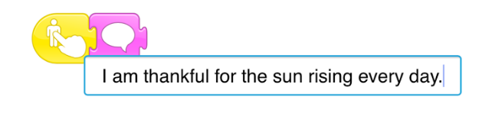

When you’re ready click on the Sprite to see what you’ve written.
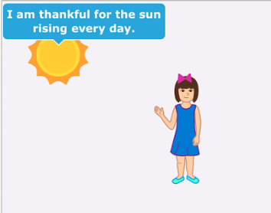

- What else are you thankful for? Keep working on the project on your own or with your partner.

