In this activity, we are going to create a maze at the end of which will be the Afikoman.
To get on Scratch go to: scratch.mit.edu and click on Create
Step One:
- The first thing we are going to do is delete the cat as we are going to want to use a different Sprite. Click on the X next to the picture of the cat on the bottom right of the screen.

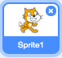

- Click on this icon to choose a new Sprite.

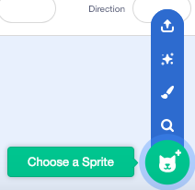

I have chosen to use Abby.

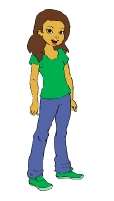

- Now we can start designing our maze. Our maze needs to be made up of only two colors. We need one color for the background and one color for the lines that the maze will move through. Here is an example of a maze:

To make the maze, you need to click on Backdrops 1. It is a white square next to your sprite at the bottom of your screen. The motion blocks will disappear on the side of your screen and there will be a Backdrops option at the top. Click on it to start editing your background.
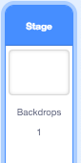

- To make your maze, choose Convert to Bitmap and click on the paint bucket tool.

Choose your color and click on your background to paint the whole background one color.

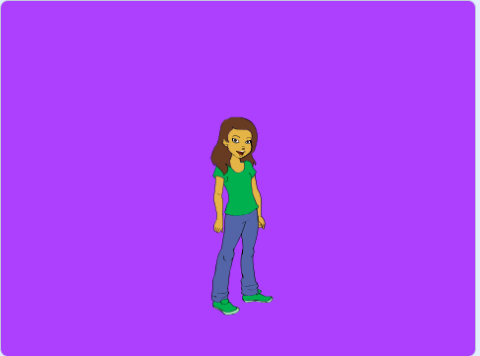

To start drawing the maze, choose the square tool and make sure that the filled option is selected.

Make your maze as creative as possible!

- Now we need to shrink our sprite so that it fits within the maze that you’ve created.
To do this, make sure that your sprite is selected and change the size from 100 to whatever size you need so it fits.

Drag it to the start of your maze so we are ready to code!

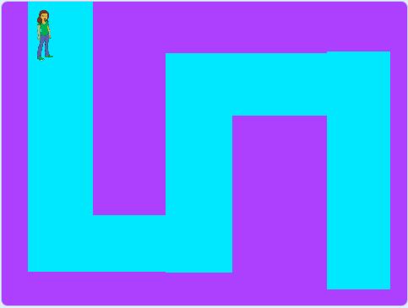
Step Two:
1. Now we can start programming our Sprite. The first thing we need to do is to put in an Event. The Event tells us how our game is going to start. We are going to use this Event:

This block tells us that our game will start when we click on the green flag. If you click on the green flag now, nothing will happen as we haven’t given it any code to run.

2. We have already put our Sprite in the start position and now we want to make sure that our Sprite is always going to be starting in the same place.

The x and y coordinates are found next to your sprite on the right of the screen.

Find where the Motion blocks are and drag this block to under your Event.

In the x and y boxes, write the numbers that are next to your sprite. Look at the numbers and make sure they match. My Sprite will be in a different position to yours so make sure that you are using the right coordinates.

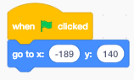

Try move your Sprite around the screen and then click the green flag.

What happens?

______________________________________________________________________

______________________________________________________________________

3. Next we are going to code the Spacebar. This is going to make our Sprite move around the screen.

Go back to Events and find this block: Drag it out to your workspace. Make sure there is enough room around it to add your code. This block doesn’t need to be connected to the other Events on the screen.

In the Motion section, find this block and connect it to the space key Event

Your code should now look similar to this:

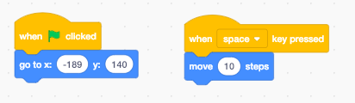

Click on the spacebar a few times and see what happens. When you’re ready to move on or you want your Sprite back at the beginning of your maze, click on the green flag.

Step Three:

1. Next we need to program the arrow keys so that our Sprite will change directions and move throughout the maze to the Afikoman.

To do this, drag another one of these blocks into the workspace:

Change the key this time to the up arrow.

2. Underneath this block we need to add a direction we want it to point in. The directions are:

Up: 0
Down: 180
Left: -90
Right: 90

To find the direction block, go to Motion and look for this block:

Change the direction to 0 and connect it to the event above.

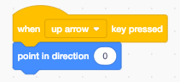

Repeat these steps until you have all four directions in your workspace

Once this is done try using the arrow keys. This should change the direction of your Sprite so that it can move around the maze.

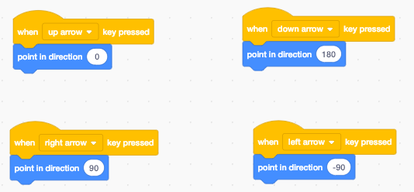

Step Four:

1. Before we start adding parts to our maze to make it more complicated, check that your Sprite is able to move around the maze without touching the outside color.

You may need to change the start position of your Sprite or make it a bit smaller.

You can also change the size of your maze if you need to.

Challenge One:

Can you make your Sprite face the same direction every time you start? Don’t worry if you get stuck. We will show you how to do this later on in the program.

I want my Sprite to face to the right every time she starts at the beginning of the maze. Can you figure out which block to use and where in the code to put it?

Hint: The Green Flag starts the program

2. We are now going to make the maze more complex as it is currently too easy to find the Afikoman!

The first thing to do is change the background. Click on Backdrops 1 to be able to make changes and click on Backdrops at the top of the screen.
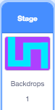

Use the text tool to write Start at the top of the maze.
The text tool looks like this:

You can write in any color/font that you want as long as you can see it on the maze.

3. Now that we can see the start of the maze, we need to include an ending. To do this, use the square tool to draw your Afikoman at the end of the maze.

Make sure that your Afikoman is a completely different color to anything else that you’ve used.

The maze should now look like this:

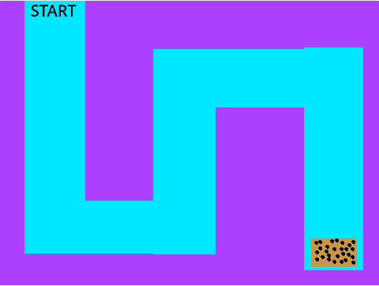

Step Five:

1. Now that we have the background ready, we want to make the maze harder to get through. In this step, we will code our Sprite so that when it leaves the path of the maze it gets sent right back to the beginning. We are also going to code it so that we know when we finish.

Find this block in the Control section of code and connect it to the code under the Green Flag.
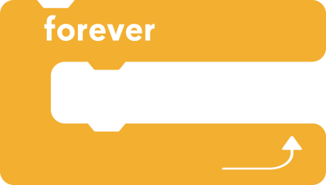

Your code should look similar to this:
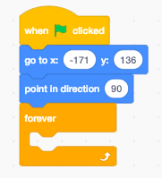

The next few blocks of code are going to go inside the Forever block.

2. Still in the Control section of code, find this block and drag it inside the Forever.

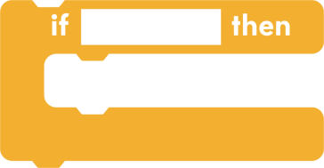

We want our Sprite to sense if it has gone off the maze. In the top part of this block, you will need to go to the Sensing section of code and find this block:

Drag it into the top part of your if_then block and click on the square at the end and choose this option.

Once you’ve clicked on this, move your mouse to your Afikoman and click on that. The square should now have changed color to match the color of your Afikoman.

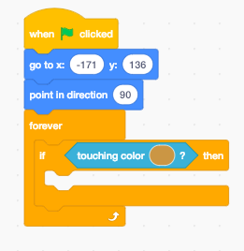

3. Find the Say for 2 seconds block from the Looks menu and write inside “Well done! You found the Afikoman!”

Your code should now look like this:

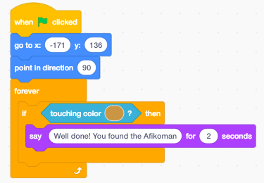

Challenge Two:

Can you make your Sprite go back to the beginning of the maze once it’s finished talking?

Hint: You have used this code already
Make sure you put this code inside your IF block underneath the Say

Challenge Three:

Can you make your Sprite go back to the beginning if it steps off the maze?

Hint: You have used this code already in the previous step

