Guess the Day of Chanukah

In this game, we are going to use variables to get our sprite to choose a random number which we will then have to guess.

To start go onto Scratch and login.

Step One: Starting to code

1. To start, delete the cat. To do this, click on the little x above the picture of the cat at the bottom of the screen. He should then disappear from the display.

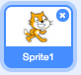

To choose a new sprite, find this image at the bottom of the display.

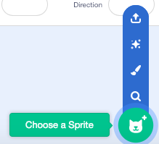

I’m going to choose the rabbit to be my sprite, but you can choose any sprite that you want.



2. You can also choose a background for your game if you want one. Choose a plain color as you want any writing or questions to be visible.

To make the background, you need to click on Backdrops 1. This will take you to an editing screen where you can paint your background.

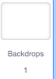

Paint the background by clicking Convert to Bitmap and selecting the paint bucket.



I’ve chosen to use a blue background.

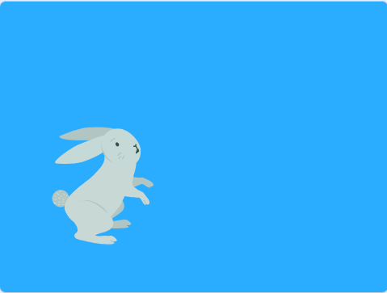

3. We are now going to start to code our sprite. Make sure that you have the sprite selected (not the background). If you have the wrong thing selected your code will not work!

The first block of code we need will come from the Events section. Your code must always start with an event or it will not run.

Drag this block into your workspace. This is the only event that we will need for this project.



All of the code that we go through now will connect back to this event block.

We now need 2 Say blocks from the Looks section. Drag them both into your workspace and connect them to the Green Flag event.

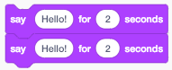

Change the number next to Hello on the top block to 1 second

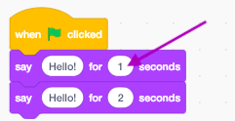

Then change the writing on the second block to say It’s Chanukah! Chanukah has 8 days.

You are now on Step Two

Guess a Number Game

So far in our game we have made our sprite say hello and explain that Chanukah is a holiday with 8 days.

To start go onto Scratch, login and open the saved game.

Step Two: Adding Variables

1. We are going to start this step by creating the variables that we need. We need 2 different variables for this project to work.

To make the variables, go to the Variable section of code and choose Make a Variable

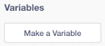

You need to create one variable called Number and one called Guesses.

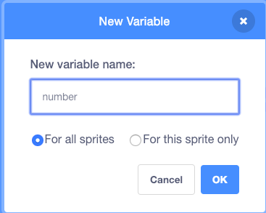

Untick the Number variable so that only the Guesses variable can be seen on the display
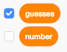

2. Now we can start programming our variables. Drag out two of these blocks to your workspace and connect them to the event above the say blocks

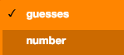

Click on the arrow on the second variable and change it to the Number variable

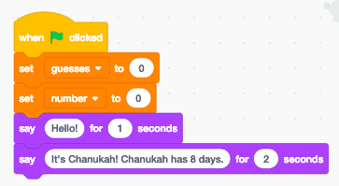

3. Keep the Guesses variable set to 0. We are going to change just the Number variable in this part. Make sure you are programming the right variable!

We want our sprite to choose a random number between 1 and 8 (8 days of Chanukah). To do this, we need to go to the Operators section of code and drag this block into a blank space in your workspace.

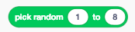

Change the numbers to say 1 and 8 and then drag the block into the space next to the Number variable like so:

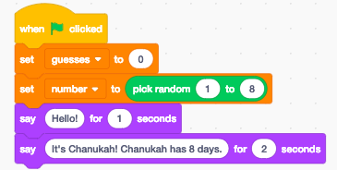

We now need to ask a question that will help us guess the number that the sprite has randomly chosen.

To do this, we need an ask and wait block from the Sensing section of code.



Change the question to: Can you guess what day it is? And drag it to the rest of the blocks of code.

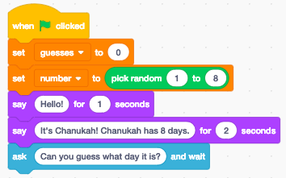

You are now on Step Three

Guess a Number Game

To start go onto Scratch, login and open the saved game.

Step Three: Too Low or Too High

1. Now we need to work out how we will know if our guess is too low or too high. To do this we need to use a repeat block with an operator inside.

Find this repeat block from the Control section of blocks and drag it into your workspace.

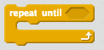

Drag inside the = operator so that your block now looks like this

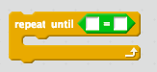

2. Inside the operator we need to put in two more blocks. We need our sprite to keep asking the question until we guess the right answer - Our answer = the number chosen

From Sensing take out an answer block and from Variables take out the Number variable.

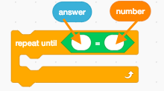

Connect the blocks into the repeat and then join it to the rest of the code

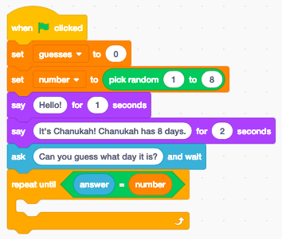

3. Go to the Variables section and drag out the following block:



Drag it into the repeat until block like this:

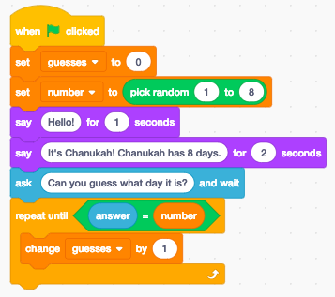

You will also need one of these blocks from the Control section of code. This is going to help our sprite work out if our guess is too high or too low.

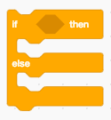

4. The next block we need is from the Operators section. We need the block with the less than symbol (<). Drag this block inside the if block.

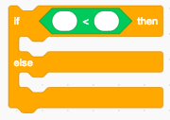

Take the same answer and number blocks that you used above and put them into this one - make sure that they are in the correct place as it will change the code if they are wrong.

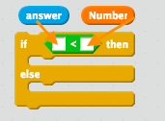

5. Next you need to drag two Say blocks from the Looks section of code and put one in each section of the if block.

Change the top one to say:

Too low for 1 second

And the bottom one to say:

Too high for 1 second

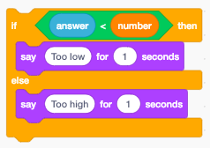

We then need the player to guess again so that they can enter in another number. For them to do this, they need to be asked another question.

From the sensing section of code drag out two ask blocks and put them in the 2 parts of the if block under the say blocks.

Change them both to say: Guess again

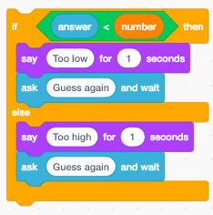

Place the if block into the repeat block and your game should work!

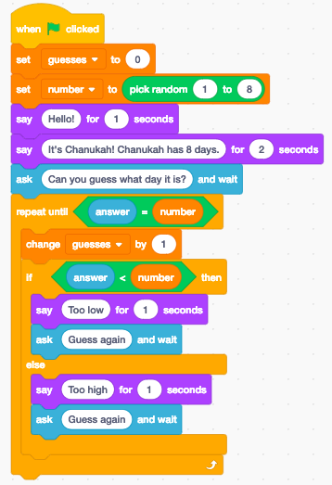

Press the Green Flag to try it out!
Guess a Number Game

To start go onto Scratch, login and open the saved game.

Step Four: Challenge Level

You now have a challenge which you should try to complete on your own or in your group.

Let’s see how far you can get!

Challenge:

At the end of your guessing game, can you make your sprite say how many guesses it took you to get the right answer?

I will give you a clue: To join different blocks together you can use this block found in the Operators section.



You can also join more than one block together and can add in variables too!



Well done for completing your game!

