Your students will make:
A music video with one of the Israeli Eurovision songs on the app Videostar.

Supplies:
- iOS (iPhone or iPad) devices, 1 per group
- Videostar app
  - https://itunes.apple.com/us/app/video-star/id438596432?mt=8
- Purchased music files from iTunes store:
  - Izhar Cohen and the Alphabeta: "A-Ba-Ni-Bi" https://itunes.apple.com/us/album/a-ba-ni-bi/990519708?i=990519960
  - Milk and Honey: "Hallelujah"
https://itunes.apple.com/us/album/hallelujah/990519708?i=990519980
  - Dana International: "Diva" https://itunes.apple.com/us/album/diva-english-radio-version/1458522155?i=1458522156
- Sample project created before the lesson
- Props to use in video: Israeli flags, any clothing, or objects that evoke Israeli culture.

Time needed:
1 lesson

Your students will learn:
In this lesson your students will connect with Israeli popular culture, from the 1970s to today, by learning and celebrating hit Israeli songs from Eurovision, the annual musical competition.

Background information:
What is Eurovision?
From Wikipedia: “The Eurovision Song Contest often simply called Eurovision, is an international song competition held primarily among the member countries of the European Broadcasting Union. Each participating country submits an original song to be performed on live television and radio, then casts votes for the other countries' songs to determine the winner.” https://en.wikipedia.org/wiki/Eurovision_Song_Contest
Official Eurovision website: https://eurovision.tv/

What does this have to do with Israel?
In 2018, Netta Barzilai’s catchy techno tune ‘Toy,’ won Eurovision, the fourth time in Eurovision history that Israel has captured this prize. The winning country hosts the competition the following year, so Israel is hosting Eurovision 2019.

What are the winning Israeli songs?
1978 - Izhar Cohen and the Alphabeta: "A-Ba-Ni-Bi"
1979 - Milk and Honey: "Hallelujah"
1998 - Dana International: "Diva"
2018 - Netta: "Toy"

Background information about Izhar Cohen and A-Ba-Ni-Bi is available at the beginning of this podcast. It’s a fascinating story - worth the listen!

Preparation:
Each iPad needs to download the VideoStar app and one of the songs from iTunes. Once the song is downloaded to the iPad, it can be opened in VideoStar.

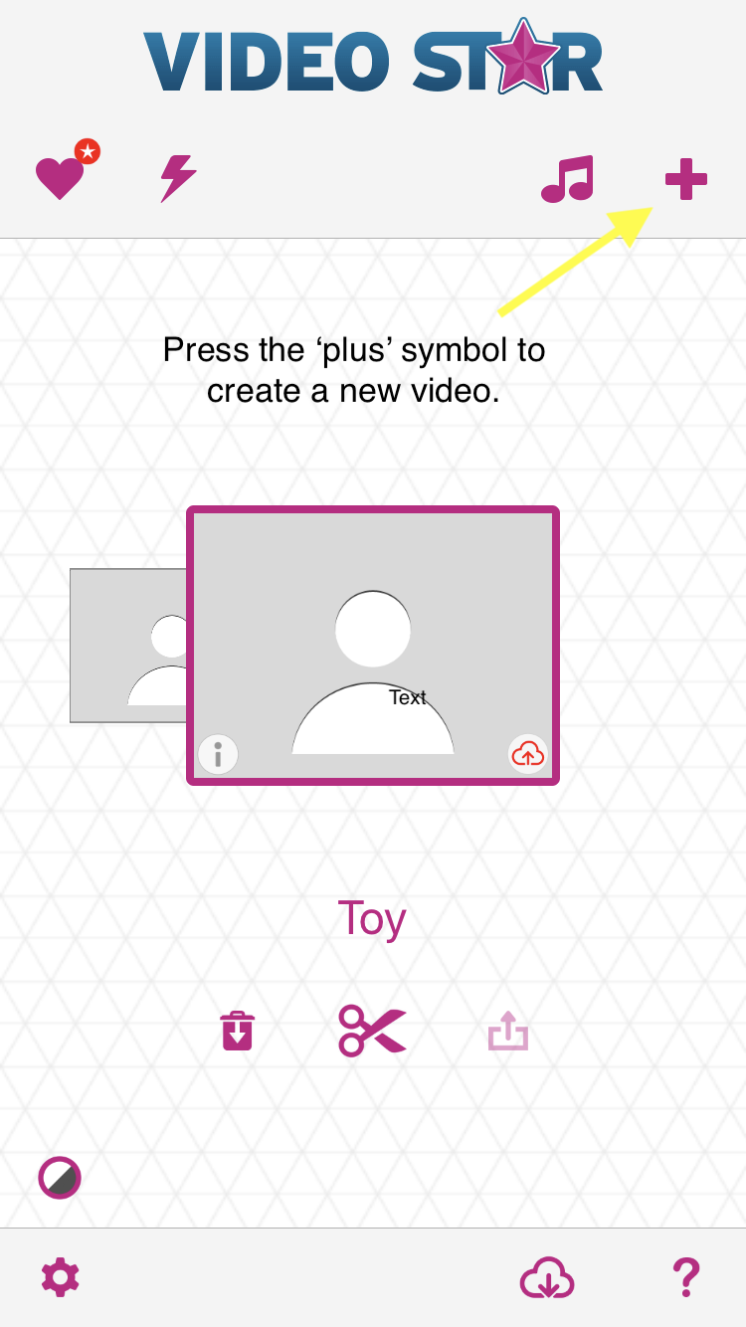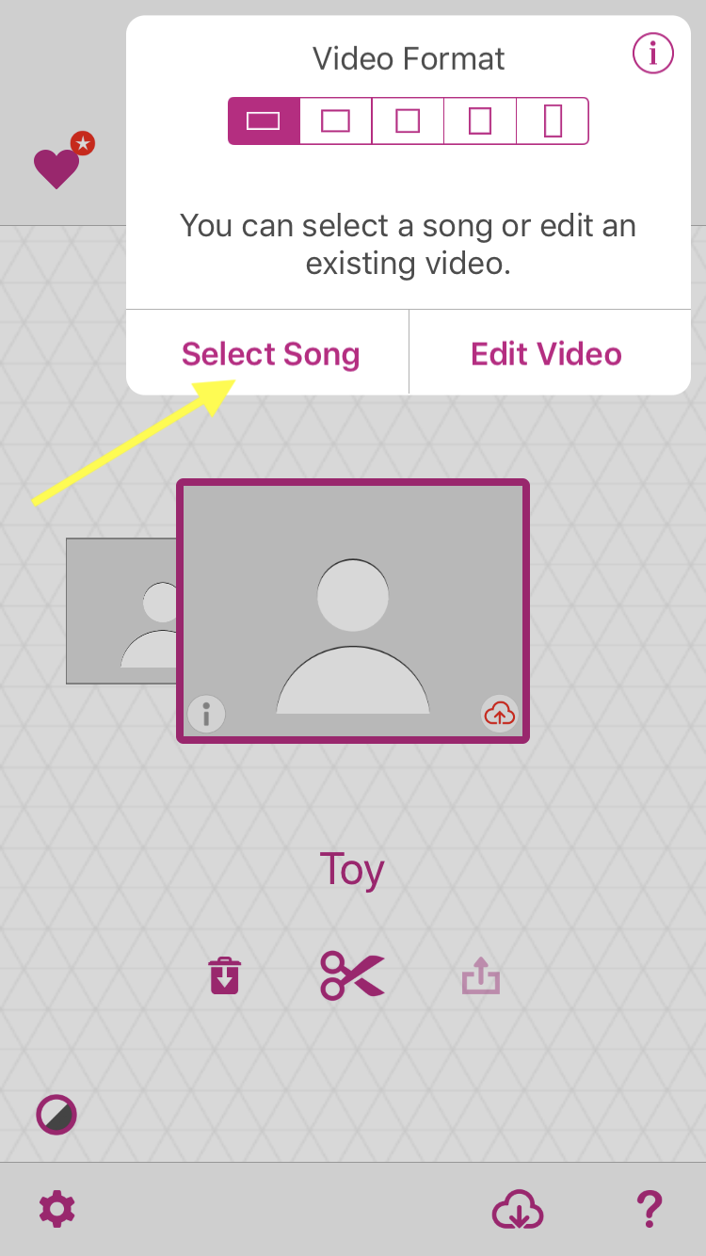

Lesson:
Introduction:
1) Start by sharing information about Eurovision and Israel. Depending on whether or not your students are familiar with the songs, you may want to play any of the following videos:

- 1978 - Izhar Cohen and the Alphabeta: "A-Ba-Ni-Bi" https://youtu.be/Q8IDx4Hmzho
- 1979 - Milk and Honey: "Hallelujah" https://youtu.be/C33kO3fvjkI
- 1998 - Dana International: "Diva" https://youtu.be/Fv83u7-mNWQ
- 2018 - Netta: "Toy" https://youtu.be/CziHrYYSyPc

2) Demonstrate the app VideoStar. Show the students a sample video that you have prepared beforehand.
3) Break the students into groups of between four to six students, and assign each group a different song. Give each group one iPad/iPhone with their assigned song loaded into VideoStar and a collection of props.
4) Groups can work on their videos for between 15 to 20 minutes, depending on the students. The program is very intuitive. There are a number of filters and special effects that can be used while recording video. Students should be encouraged to dance along with the music, while waving flags or otherwise using the props. Tell groups that they don’t need to record a video that lasts the duration of the song; however much they create is sufficient. You might also want to encourage students not to over-think or over-plan their video. This is meant to be fun.
5) Bring all the groups together and play the videos on a projector for all to see. If you want to share the videos, save them from the VideoStar app to the Camera Roll. From there, you can email the videos, upload them to Google Drive or AirDrop them to a nearby MacBook.

VideoStar Tips:
- Video Star - A Complete Guide to Beginners to use Video Star!
- Wiki How: Make a Music Video with Video Star

Extensions:
- If you want additional songs, Golden Boy (2015) https://youtu.be/NdxOCTezeTg is also popular although it didn’t win the competition.
- Provide students with a printout of the song’s lyrics and biographical information about the singer and composer.
- Discussion questions:
  - What can we learn about Israel in 1977, 1978, 1998 and 2018 by studying the official song of the year?
  - What language is used in the songs? How does it change over the years?
  - Eurovision is an international competition. What can we learn about Israel based how the singers represent the country to the rest of the world?

