Your students will create:
A Scratch Jr. program showing how Ruth chose to follow Naomi in Megillat Ruth.

Supplies:
- iPads or tablets
- Scratch Jr app https://www.scratchjr.org/
- Sample project created by the teacher before the lesson

Time needed:
1 - 2 lessons

Learning goals:
Students will learn how to copy code from one sprite to another. They will also learn how to use the Send Message and Start on Message blocks to pass control from multiple sprites.

Coding concepts and computational thinking:
Algorithm: People follow and create processes as part of daily life. These processes can be expressed as algorithms that computers can follow.
Debugging: Things don’t always work on the first try. Many iterations are usually necessary to get it right (in coding and in life).
Control Structure: Computers follow precise sequences of instructions that automate tasks. Program execution can also be non-sequential by repeating patterns of instructions and using events to initiate instructions.
This lesson assumes students have a basic familiarity with Scratch Jr. If this is not the case, you might want to start with the Modeh Ani Scratch Jr. lesson or another introduction to the Scratch Jr. platform.

Lesson:
Introduction:
Share the story of Ruth and Naomi from the Book of Ruth, with emphasis on “Wherever you go, I will go.” You might want to use some of the JI-Tap Shavuot resources, especially the game The Story of Rut or this blog post.
Your students may enjoy The Book of Ruth: a music video for Shavuot from Bim Bam.

Discussion questions:
- What does it mean to go ‘where you go?’
- What commitment is Ruth making? What is she giving up? What is she gaining?
- What does it mean to follow someone?
Program Challenge:
Students create a Scratch Jr. program, demonstrating how Ruth follows Naomi.

Step by step directions:
- Create a new program.
- Delete the Scratch Cat.
- Create Ruth and Naomi sprites,
  - select the sprite.
  - rename it
  - edit/color if desired.
- Program Naomi to move across the screen using the blue movement blocks. The numbers can be changed to repeat the movement numerous times.
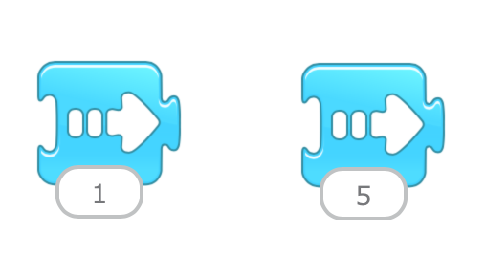
Students should be encouraged to use multiple blue movement blocks to create an interesting path.

- Copy Naomi’s code blocks to Ruth, by holding a finger on the blocks and dragging them to the Ruth sprite.
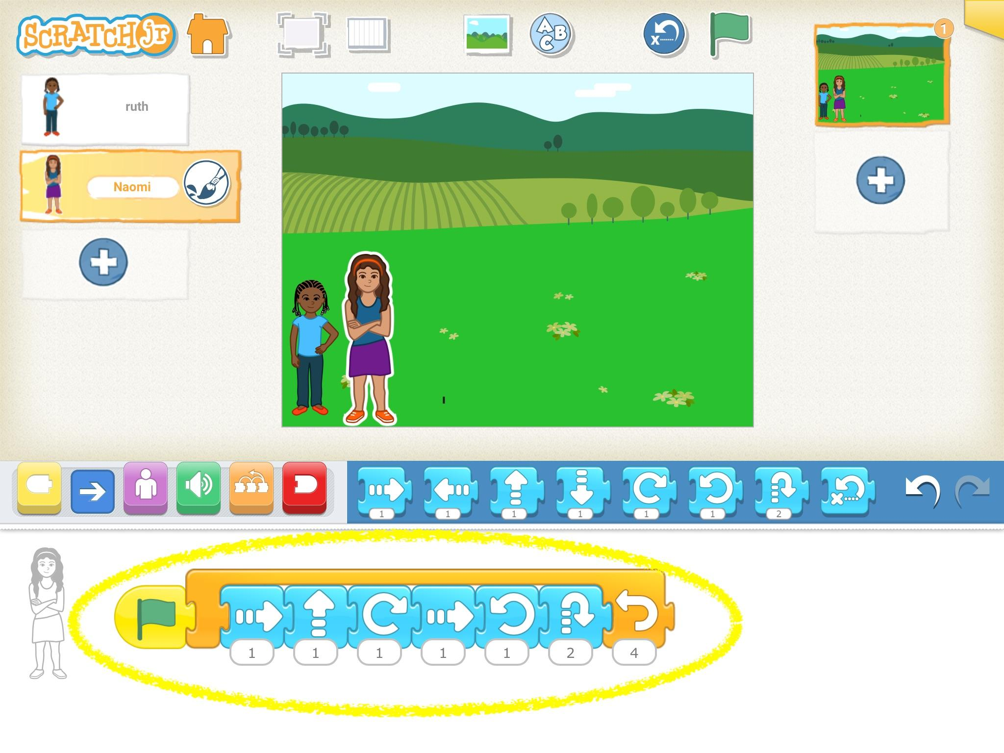

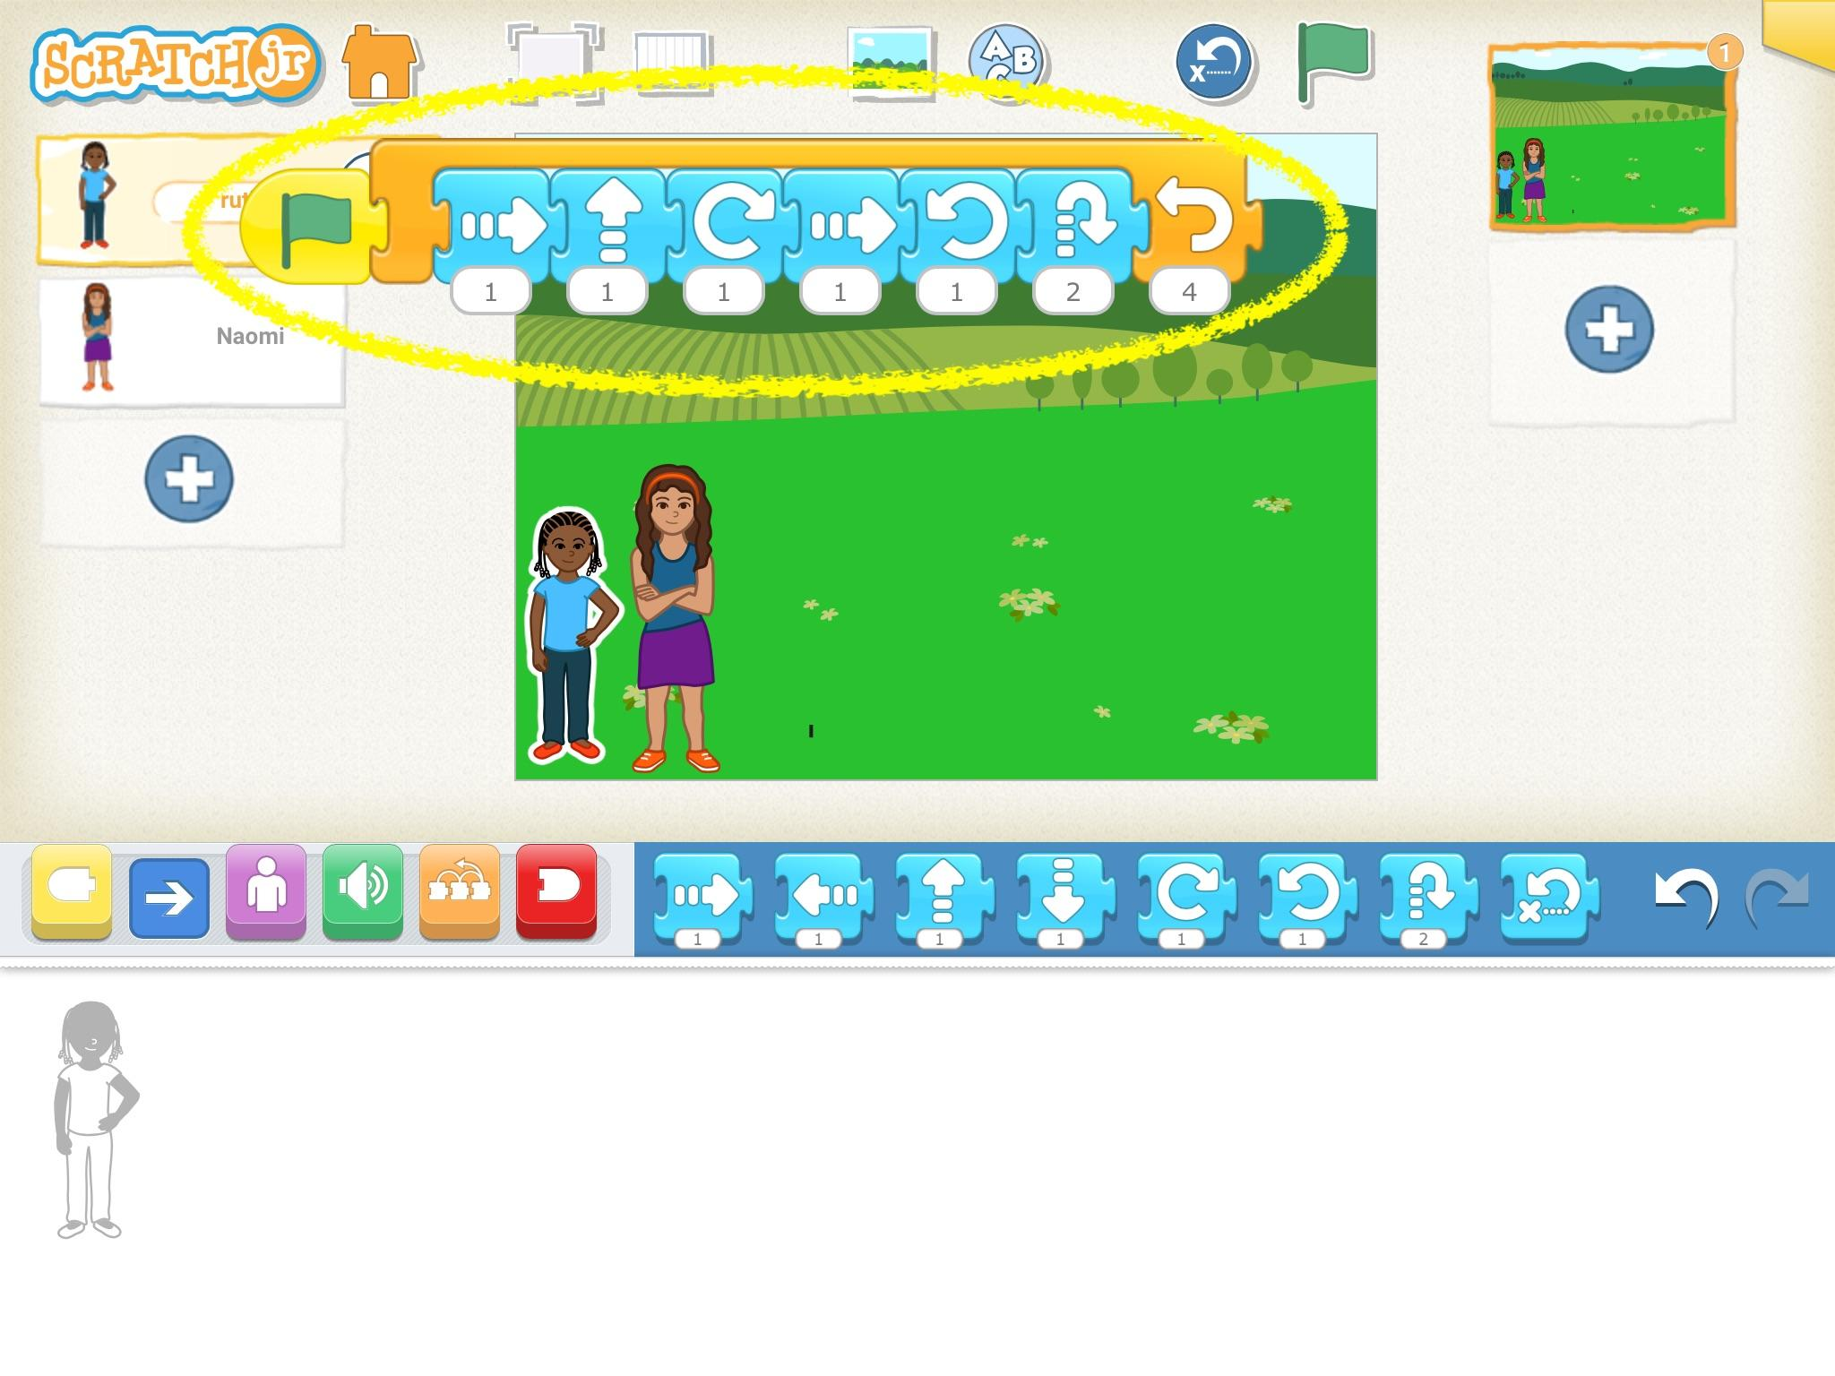

- Sequence the movement, so that first Naomi moves across the street. This can be done either by using the Timer block, to make Ruth wait, or using the Send Message and Start on Message blocks.
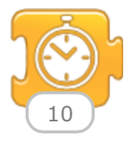 | The timer block pauses the program for a specified period of time. The number represents tenths of a second. Students will have to use trial and error to determine how long Ruth should wait until following Naomi.
 | The send message block sends a message of the specified color, which can be received by another sprite. Naomi can send this message when she has completed her movement, indicating that it is time for Ruth to follow.
 | The start on message block starts the program when the message from the specified color is received. Ruth will wait to receive the message from Naomi, and then she will follow, “wherever she goes.”

Extensions:
As students complete the basic requirements of the task, encourage them to try the following extensions:
- Add to the story. Instead of moving along a white screen, add a background so there is more of a story. Where are Ruth and Naomi? In the fields? At home? At school? In the park?
- Include dialogue. Students can record themselves to give voices to Ruth and Naomi, in either Hebrew or English.
- Use the repeat blocks to make the program more efficient and use less code.

References:
The Official Scratch Jr. Book by Marina Umaschi Bers & Mitchel Resnick
Scratch Jr. website: www.scratchjr.org

