Students will create:
A Rosh Hashanah birthday card for the world, using Scratch Jr.

Recommended Student age:
Kindergarten - 2nd grade

Supplies:
- iPads, Android tablets, Amazon Kindles or Chromebooks
- Scratch Jr app https://www.scratchjr.org/
- Optional: sample project created by the teacher before the lesson

Time needed:
1 - 2 lessons

Learning goals:
Students will learn how Rosh Hashanah is considered the birthday of the world and how to make a program with multiple scenes in Scratch Jr.

Coding concepts and computational thinking:
Algorithm: People follow and create processes as part of daily life. These processes can be expressed as algorithms that computers can follow.
Debugging: Things don’t always work on the first try. Many iterations are usually necessary to get it right (in coding and in life).
This lesson assumes students have a basic familiarity with Scratch Jr. If this is not the case, you might want to start with the Modeh Ani Scratch Jr. lesson or another introduction to the Scratch Jr. platform.

Lesson:
Introduction:
Rosh Hashanah, the Jewish New Year, is a time for celebrating the creation of the world and resolving to help the earth and its inhabitants in the upcoming year. Ask students:
What would you like to do/give to the world as a birthday present? How can the world celebrate a birthday?
You may want to introduce the lesson using any of these resources:
- The World's Birthday: A Rosh Hashanah Story by Barbara Golding
https://www.amazon.com/Worlds-Birthday-Rosh-Hashanah-Story/dp/0152000453
- Hayom Harat Olam Happy Birthday to the world song by: Elana Light https://www.youtube.com/watch?v=cBfS8RC-lj0
- The Rosh Hashanah Shaboom! Special: Be the Best Me
https://www.youtube.com/watch?v=daQozUHX2Yo
- Happy Birthday, World: A Rosh Hashanah Celebration
https://www.amazon.com/Happy-Birthday-World-Hashanah-Celebration/dp/0929371321
- Today is the Birthday of the World, By Linda Heller
https://www.penguinrandomhouse.ca/books/300297/today-is-the-birthday-of-the-world-by-linda-heller-illustrated-by-alison-jay/9780698168350

Program Challenge:
Students create a birthday card for the world, using Scratch Jr.
Students should be encouraged to be creative and develop unique projects. The step-by-step directions below are merely one suggestion of how to make a Rosh Hashanah birthday card. Provide your students as much guidance as necessary, but keep in mind the goal is for them to be as independent, creative and unique as possible.

Programming suggestions:

Scene 1 - “Shana Tovah.”
In the sample program, we added the Earth and two Hebrew words: שנה טובה (Happy New Year).

To create a Hebrew word, first click on the blue plus sign to add a new sprite. | 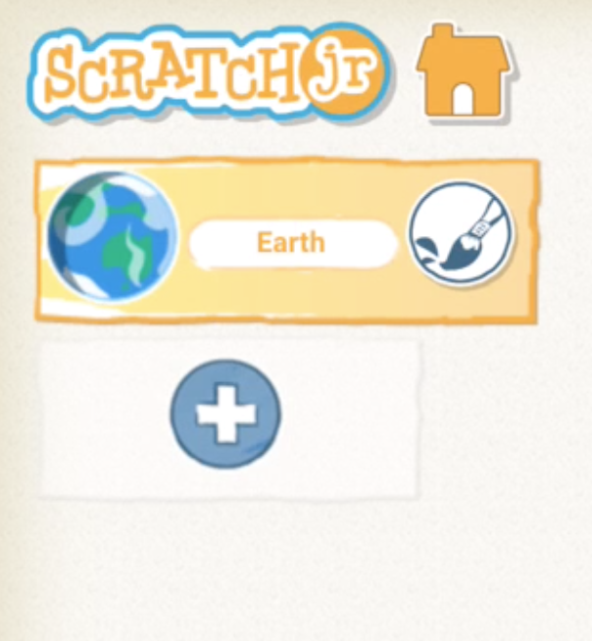
To edit a blank sprite select the paintbrush. | 
Select the drawing function, and use your finger the write the Hebrew letters ‘שנה’  Repeat these steps for the Hebrew word ‘טובה.’ | 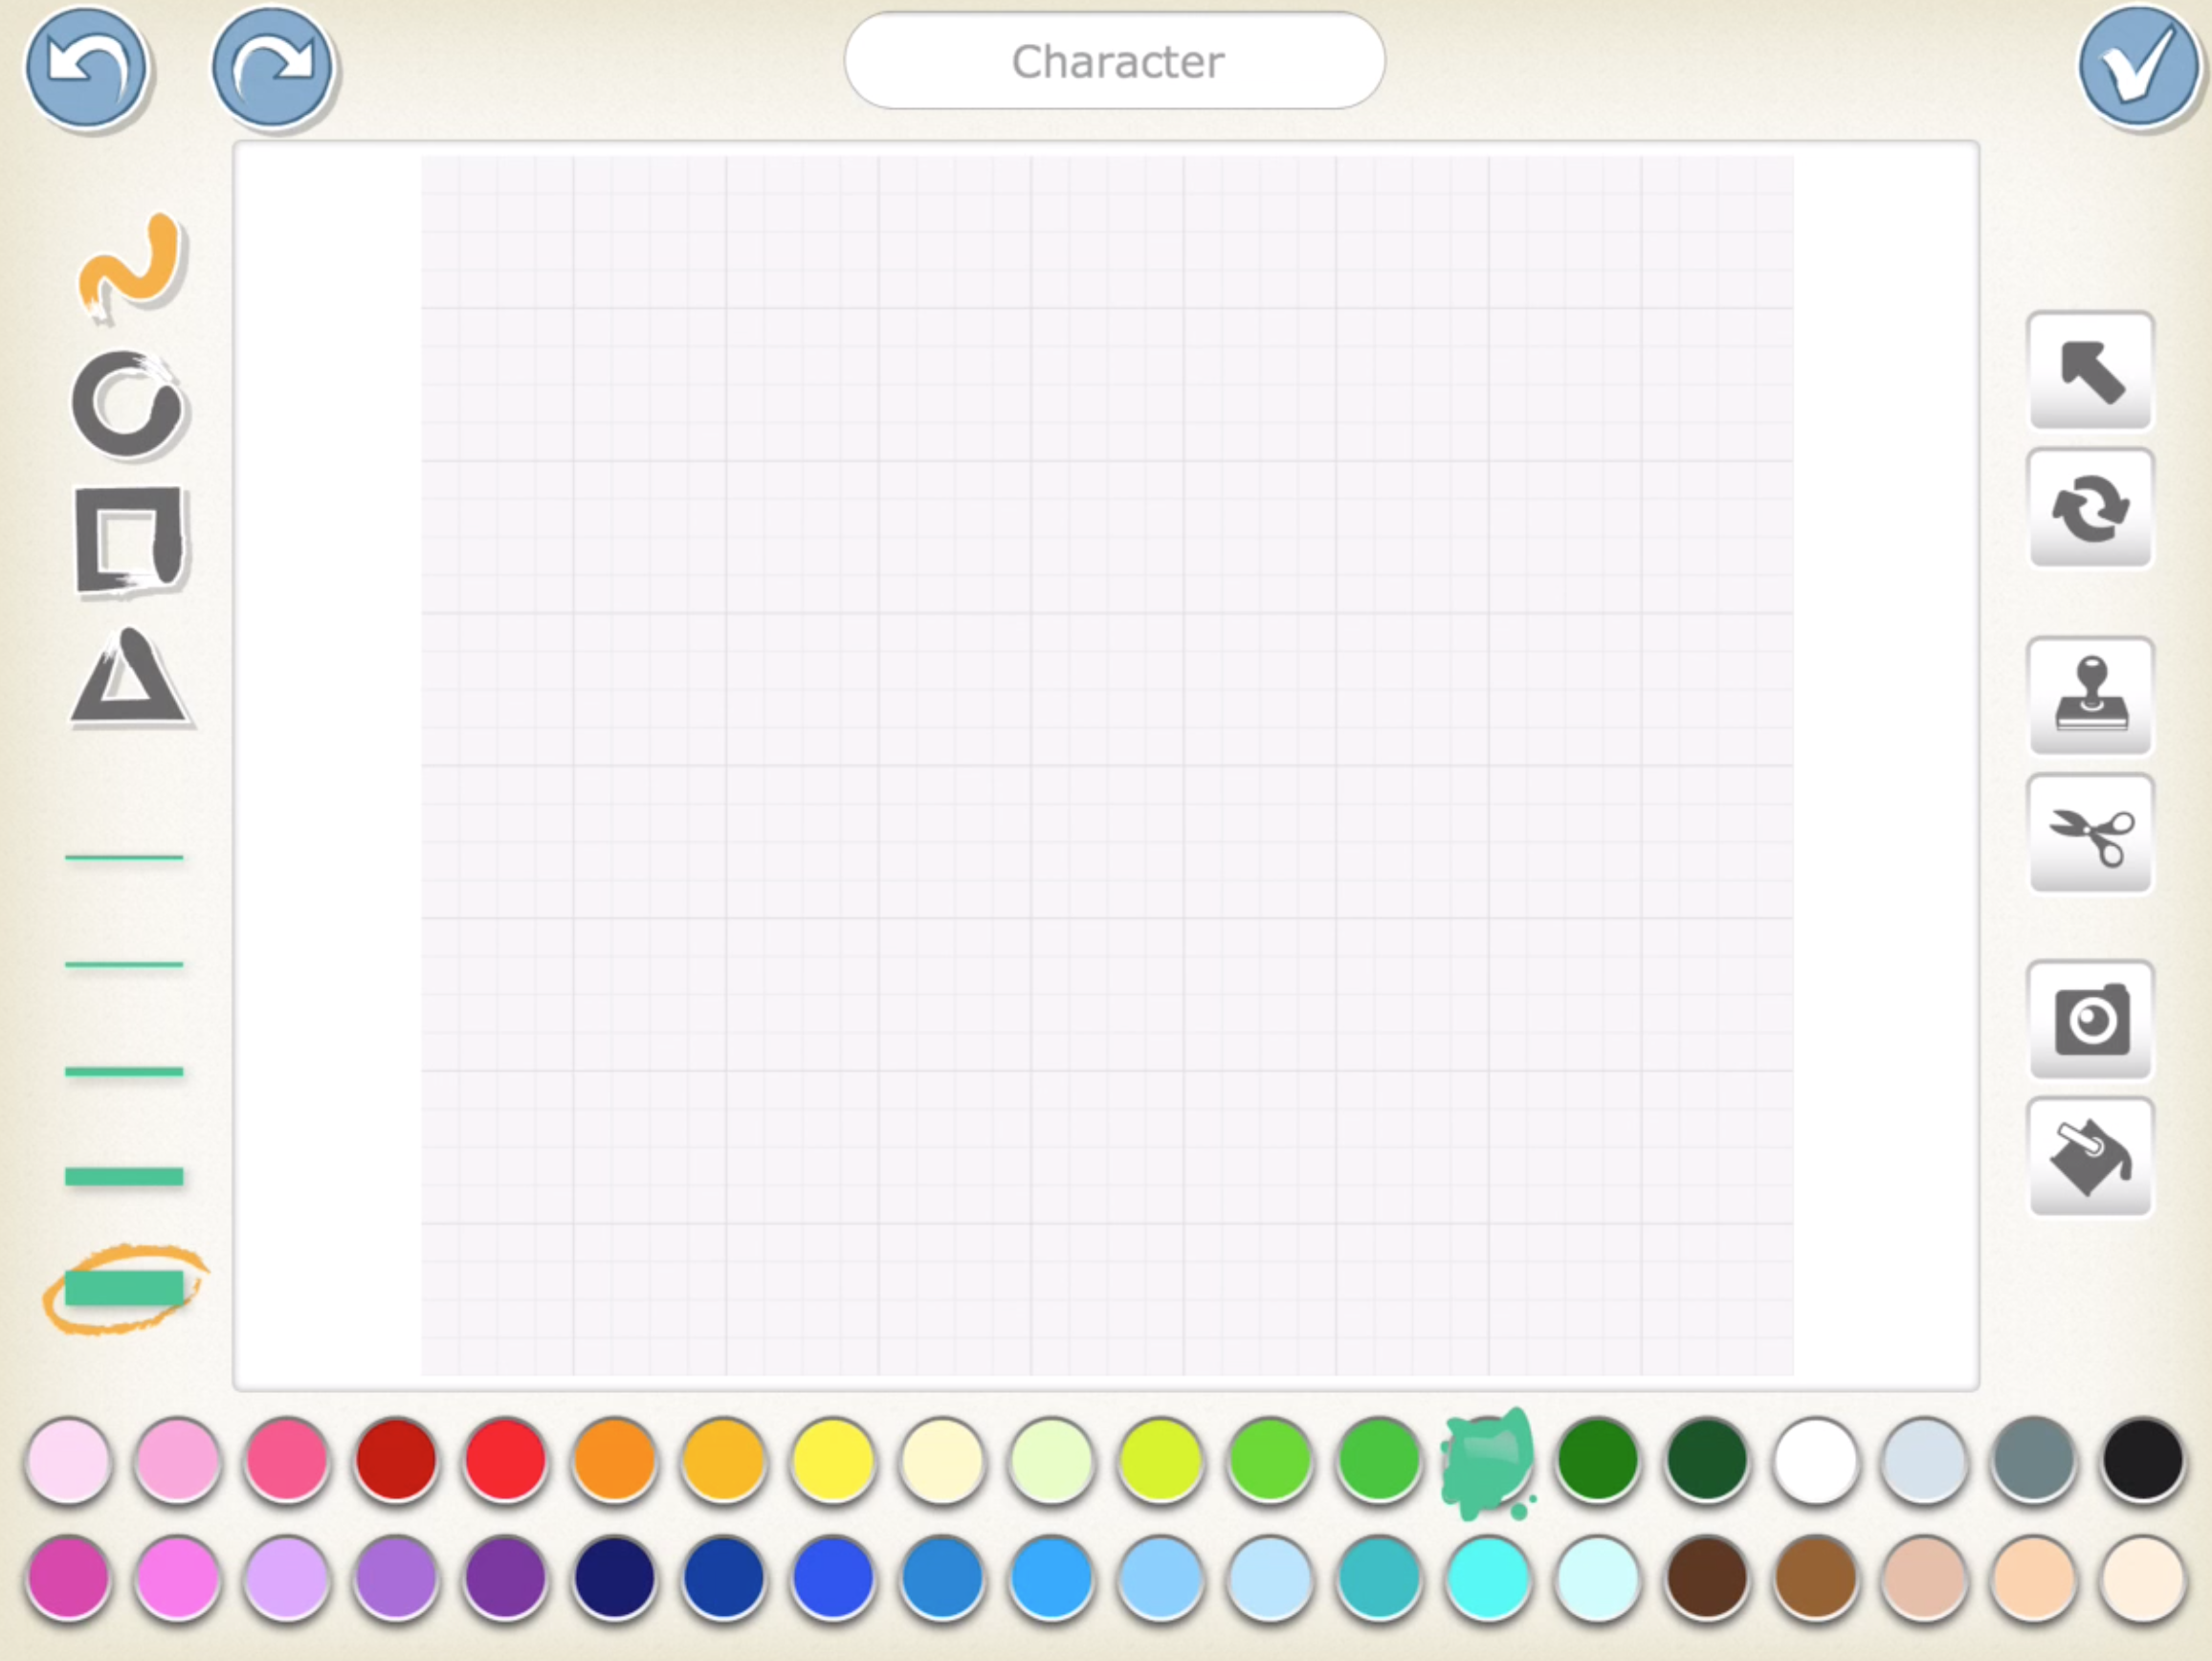
 | 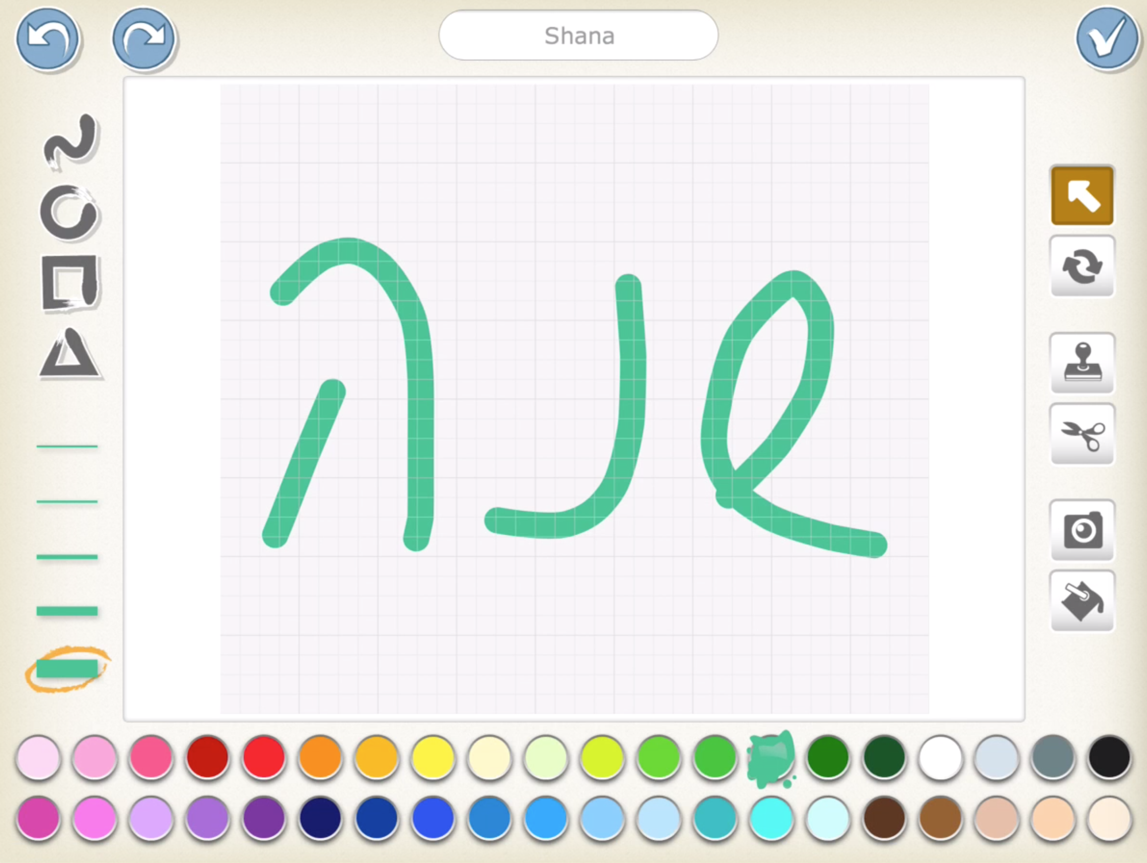
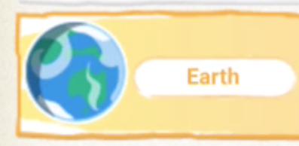 | 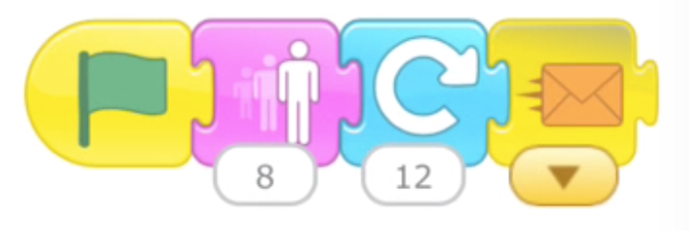Using these blocks the earth will grow 8 times and then spin 12 times, making a full circle, to represent a full year.
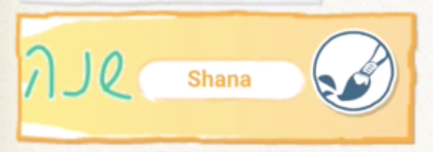  These blocks will make the sprite ‘שנה’ hide at the beginning of the program, appear when it receives the orange message, then grow and shrink on the screen. When it is done it will send a red message to the other sprites. | 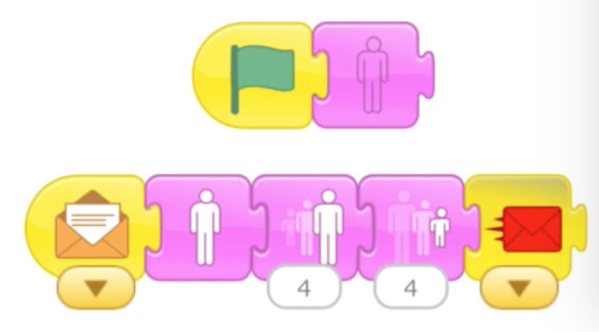
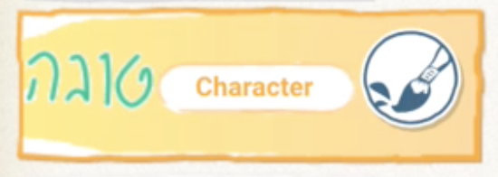  These blocks are for the ‘טובה’ sprite. It will disappear at the beginning of the program, then reappear when it receives the red message from the שנה sprite. Then it will grow, shrink and move to the second scene. | 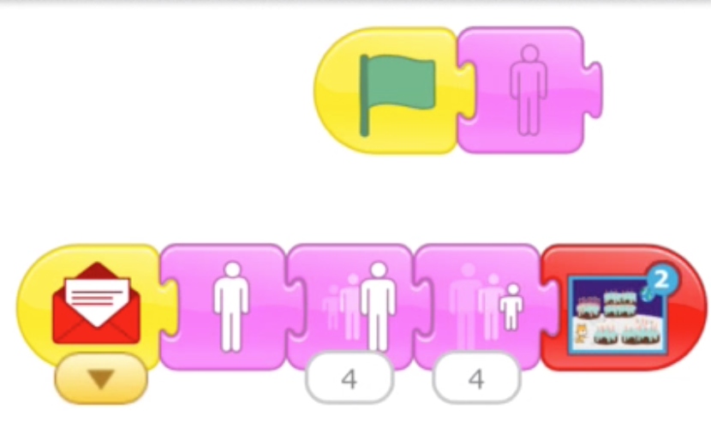

Scene 2 - Wishing the world happy birthday.
In this program, students learn how to use the red blocks to create multiple scenes in a Scratch Jr. program.  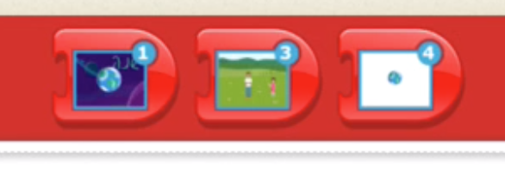 | 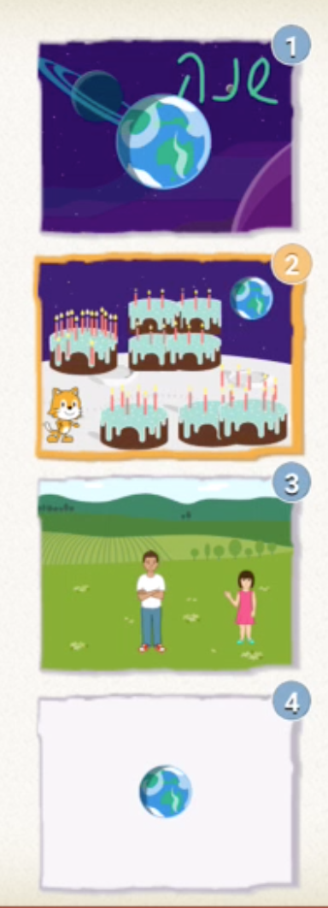

In scene two of the program, the cat wishes happy birthday to the world and multiple birthday cakes appear.

The cat makes a Rosh Hashanah greeting, then send the Orange message. | 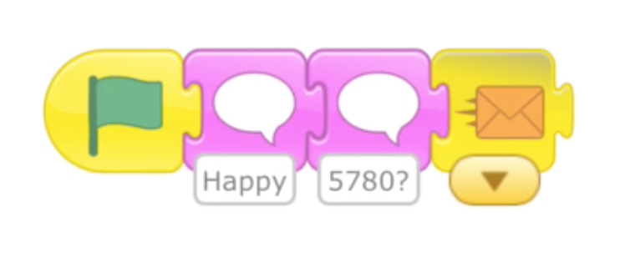
The cake disappears at the beginning, reappears when it receives the orange message, then sends a red message. | 
The ‘double cake’ sprite disappears at the beginning, reappears when it receives the red message, then sends a yellow message. | 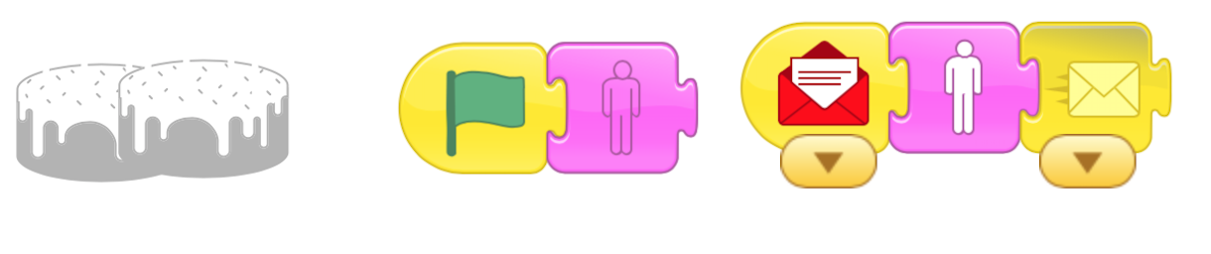
The ‘lots of candles cake’ sprite disappears at the beginning, reappears when it receives the yellow message, then sends a green message. | 
The ‘four cakes’ sprite disappears at the beginning, reappears when it receives the green message, waits for 10 moments, then advances to scene 3. | 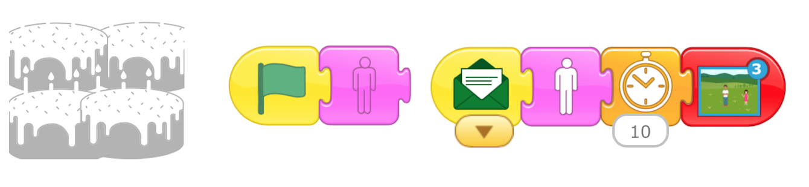

Scene three: A birthday / Rosh Hashanah wish for the world.
Students can put themselves into the card, by following these directions:

- Select one of the sprites with a blank face.

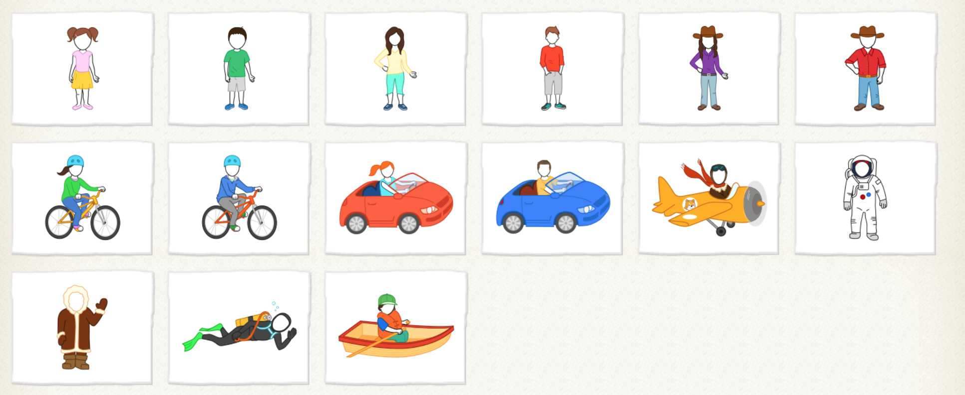

2) Select the ‘Camera’ function and then select the blank face.

Note: If the camera button does not appear on this screen, it is because the device has not given Scratch Jr permission to use the camera. Under Settings, select Privacy and give permission to Scratch Jr to use the camera.

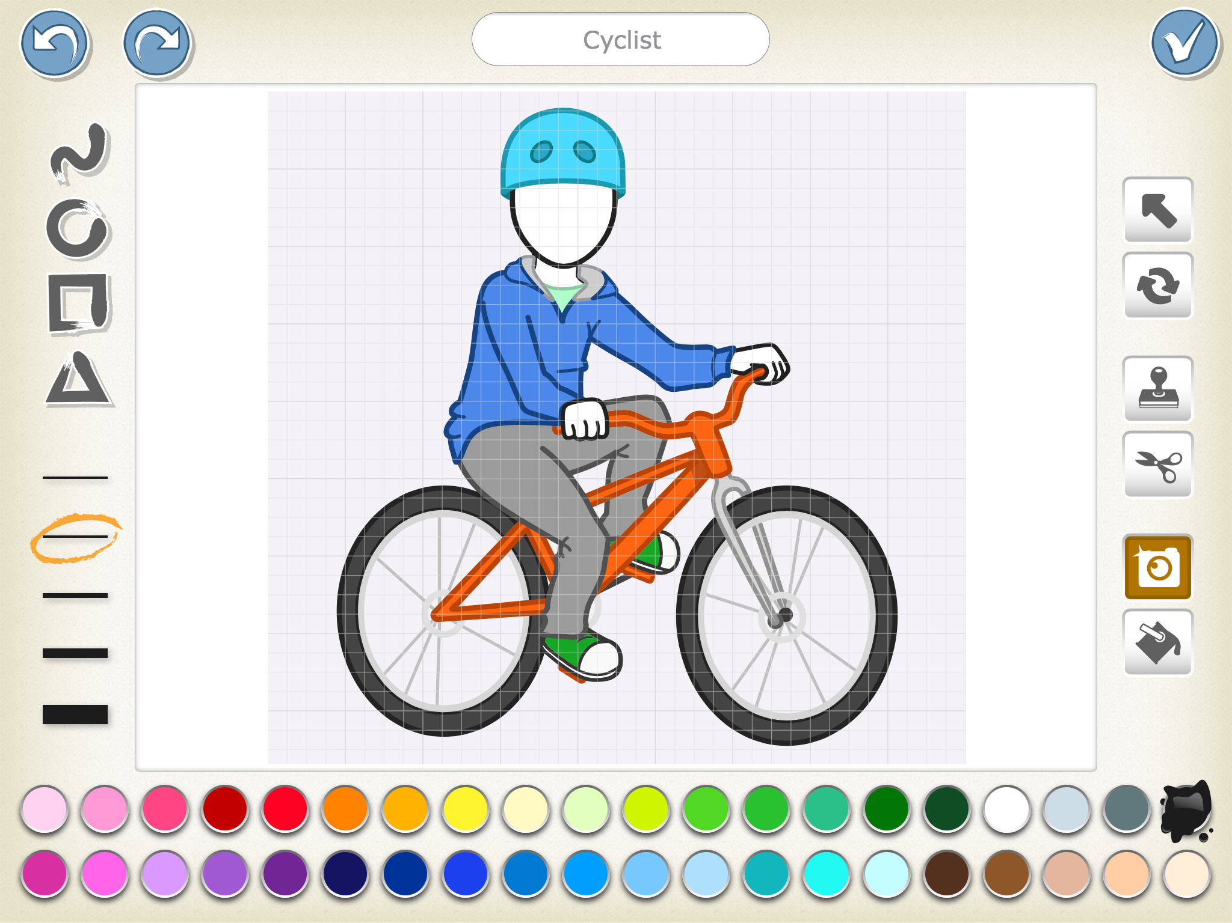
Camera
Face to fill with photo
3) The blank face will now show an image from the camera. Point the camera at your face. This can be tricky, and some children may prefer to have a partner hold the device to take the photo. Remember to look at the camera, not the image on the screen. Press the Camera image to take a photo. You can re-take the photo until you are satisfied with the result. 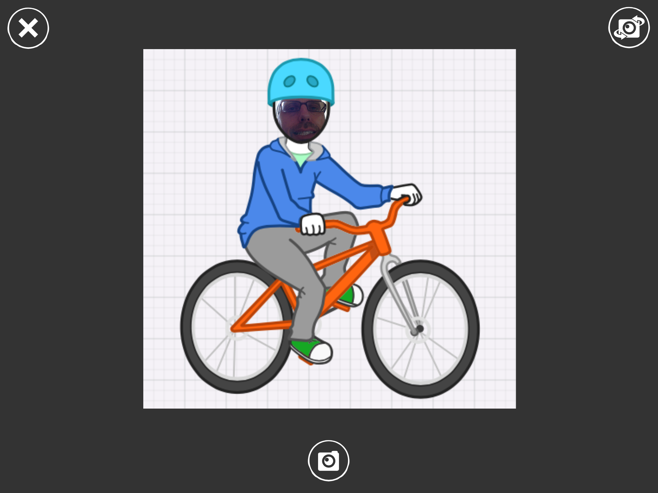

4) The image will now be in the program, with your face. Program the sprite to say a wish for the world, in either typed words or recording your voice.

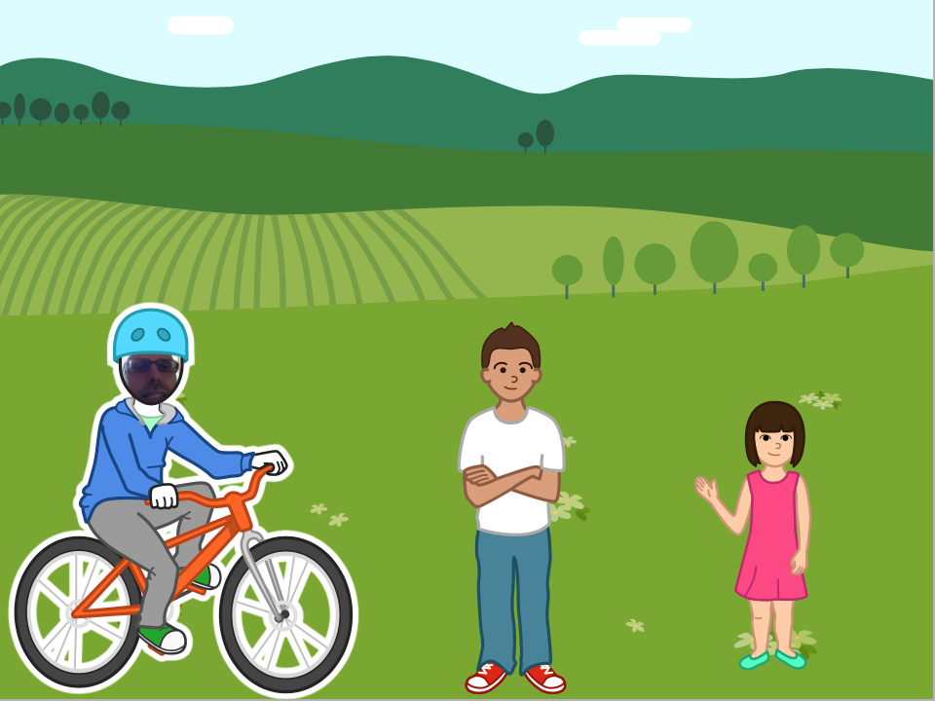

References:
The Official Scratch Jr. Book by Marina Umaschi Bers & Mitchel Resnick
Scratch Jr. website: www.scratchjr.org

