Students will create:
A shofar program that demonstrates the three shofar blast sounds.

Recommended student age:
Kindergarten - 2nd grade.

Supplies:
- iPads, Android tablets, Amazon Kindles or Chromebooks
- Scratch Jr. app https://www.scratchjr.org/
- Optional: sample project created by the teacher before the lesson
- A shofar and someone who can blow it. If this is not possible, use this link for recordings of shofar blasts.

Time needed:
1 - 2 lessons

Learning goals:
Students will learn the different shofar blasts and how to control characters in Scratch Jr. by using events to initiate instructions, i.e. start when touched.

Coding concepts and computational thinking:
Modularity:
A computer program is a set of commands created by people to do something.
Complex tasks can be broken down into simpler instructions, some of which can be broken down even further.

Control Structure:
Computers only follow the program’s instructions.
Computers follow precise sequences of instructions that automate tasks. Program execution can also be nonsequential by repeating patterns of instructions and using events to initiate instructions.

Coding skills:
Students will be able to:
- Create a simple computer program.
- Break up programming task into parts that are inter-dependent or recursive.
- Use control structures to specify the flow of execution.
- Understand how control is passed through message blocks.
This lesson assumes students have a basic familiarity with Scratch Jr. If this is not the case, start with the Modeh Ani Scratch Jr. lesson or other introductory lessons.

Lesson:

Introduction:
On Rosh Hashanah, Jews all over the world blow the shofar. There are three different types of shofar blasts: tekiah, t’ruah and sh’varim (Four if you count the big one, tekiah gedolah!).

Program Challenge:
Students code shofar programs to demonstrate each of the different ways of blowing the shofar.
As with all coding projects, students should be given the opportunity to be creative and ideally develop their unique way to fulfil the project requirements. The step-by-step directions below are one way to create a Scratch Jr. shofar project. Keep in mind that you want to provide your students with necessary support, but the goal is always for them to be as independent, creative and unique as possible.

Programming suggestions:

1. Create the shofars.
Click on the blue plus sign on the left of the screen to add a new character.
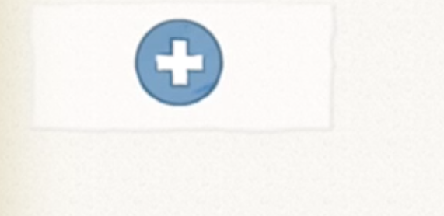
Open the paint editor by tapping the paintbrush.

Select the drawing function and use your finger to draw a shofar. In a different color, label the shofar according to the sound it will make in either Hebrew תקיעה or English tekiah.
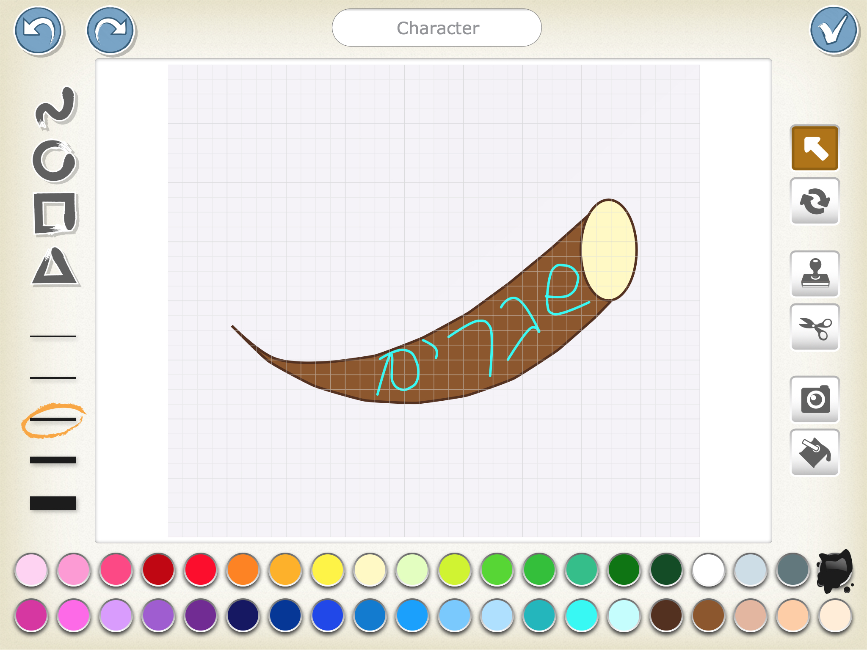

Repeat these steps to create shofarot for the other sounds: teruah and sh’varim.

2. Record audio for each of the shofar sounds.
Tap the green audio block to select the sound blocks.
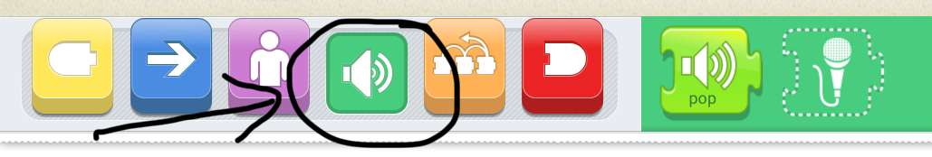
Select the microphone.
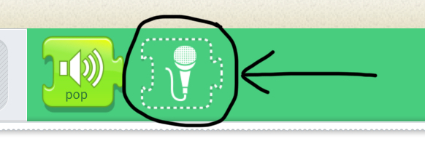
Tap the round record button to record the shofar blast, the square stop button to stop recording and the triangle play button to hear the recording. If the recording does not turn out how you hoped, you may re-record it until it is satisfactory. When it is ready, tap the checkmark to save it. If you have an actual shofar and someone to blow it, then use them. One person will press the record button, and then the shofar blower will make the sound. If you don’t have access to a shofar, use pre-recorded shofar sounds, available here.
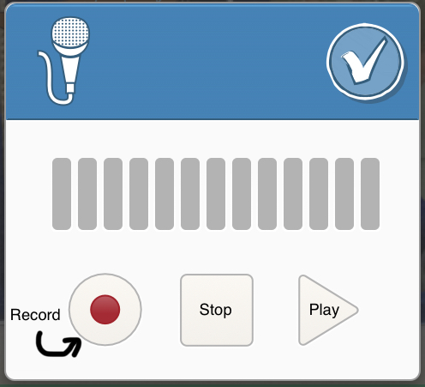
Once the audio file is saved, it will create a green ‘Play Recorded Sound’ block with a microphone and a number. The sound block can then be added to the shofar’s script. This block only works for the sprite where you recorded it, so make sure you record the correct shofar blast else you will have to switch characters and re-record the sound.

3. Program the shofar to blast when tapped.
Use the ‘Start on Tap’ block, to have the shofar start its script when the user taps it.
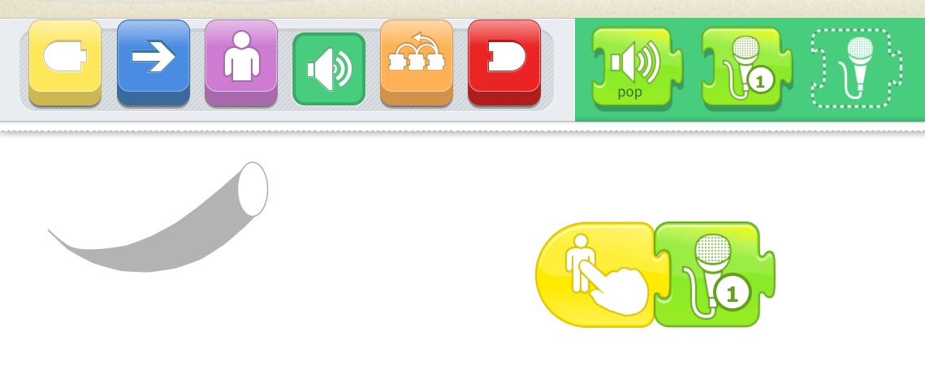

Extensions:
Now that you have the basics of the program, there are many possible extensions that you can add to the program. Here are some ideas:
- Add a character to blow the shofar.
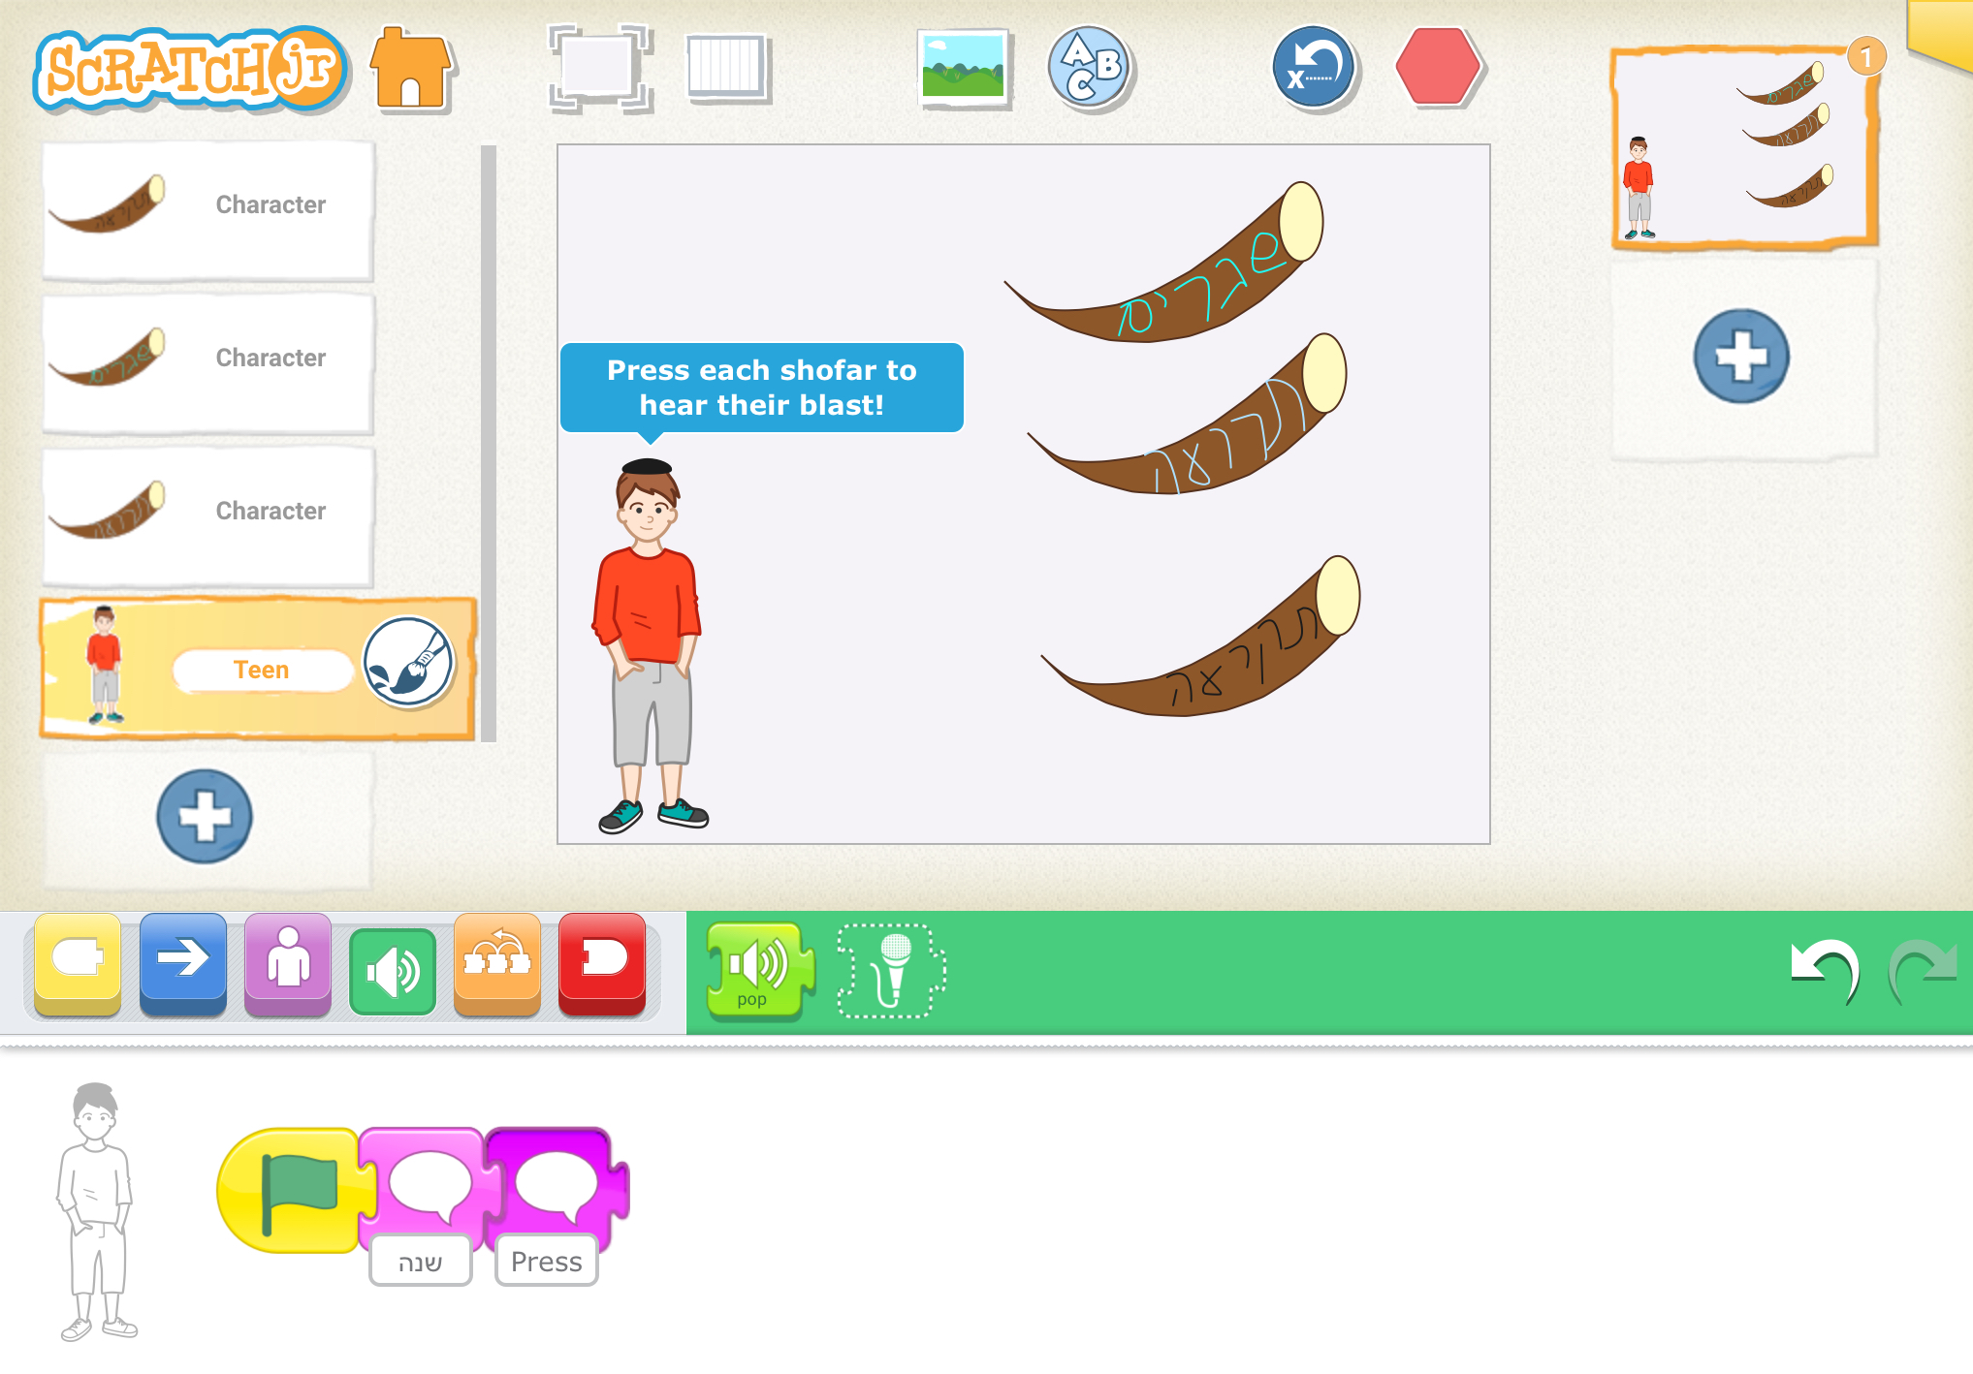
- Change the program so that the shofars blast when they touch the shofar blower, rather than when tapped. You will need to use the ‘Start on Bump’ block.
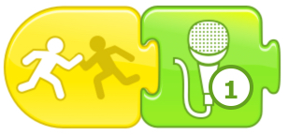
- Record someone saying the name of the shofar blast, before you hear the shofar.
- Create a matching game, where users hear a blast and then must tap the correct shofar.
- Make musical notes coming out of the shofar when it blasts.
- Create one shofar that can make all the sounds. You will need to record multiple recordings on one shofar sprite and figure out how to tell it when to make each sound. Hint: try using the message blocks.

References:
The Official Scratch Jr. Book by Marina Umaschi Bers & Mitchel Resnick
Scratch Jr. website: www.scratchjr.org

