Overview:
In this lesson, students create a ScratchJr. program for Sukkot that includes shaking the lulav, inviting guests to the sukkah and watching the stars twinkle. This programming project gives the students a chance to apply their knowledge of the movement blocks, the repeat control structure.
This lesson assumes students have a basic familiarity with Scratch Jr. If this is not the case, start with the Modeh Ani Scratch Jr. lesson or other introductory lessons.

Recommended student age:
Kindergarten - 2nd grade.

Supplies:
- iPads, Android tablets, Amazon Kindles or Chromebooks
- Scratch Jr. app https://www.scratchjr.org/
- Optional: sample project created by the teacher before the lesson

Time needed:
1 - 2 lessons

Learning goals:

Jewish content:
- On Sukkot, we shake the lulav.
- On Sukkot, we invite guests to join us in the sukkah.

Coding concepts and computational thinking:
- Control Structure: Program execution can be nonsequential by repeating patterns of instructions and using events to initiate instructions.

Students will be able to:
- Combine pieces of different programs to achieve a goal.
- Purposefully use and understand the effect of a repeat loop.
- Break up programming task into parts that are interdependent or recursive.
- Use control structures to specify the flow of execution.

Lesson:

Introduction:
Two important rituals during the holiday of Sukkot are shaking the lulav and inviting guests to your sukkah.

Programming Challenge:
Code a program that demonstrates:
- shaking the lulav
- inviting guests to the sukkah
- watching the stars in the night’s sky, from the sukkah
As with all coding projects, students should be given the opportunity to be creative and ideally develop their unique way to fulfil the project requirements. The step-by-step directions below are an example of one way to create the project. Provide students with necessary support but the goal is always for them to be as independent, creative and unique as possible.

Programming suggestions:

Create a lulav
Open the Paint Editor and draw a lulav and etrog.
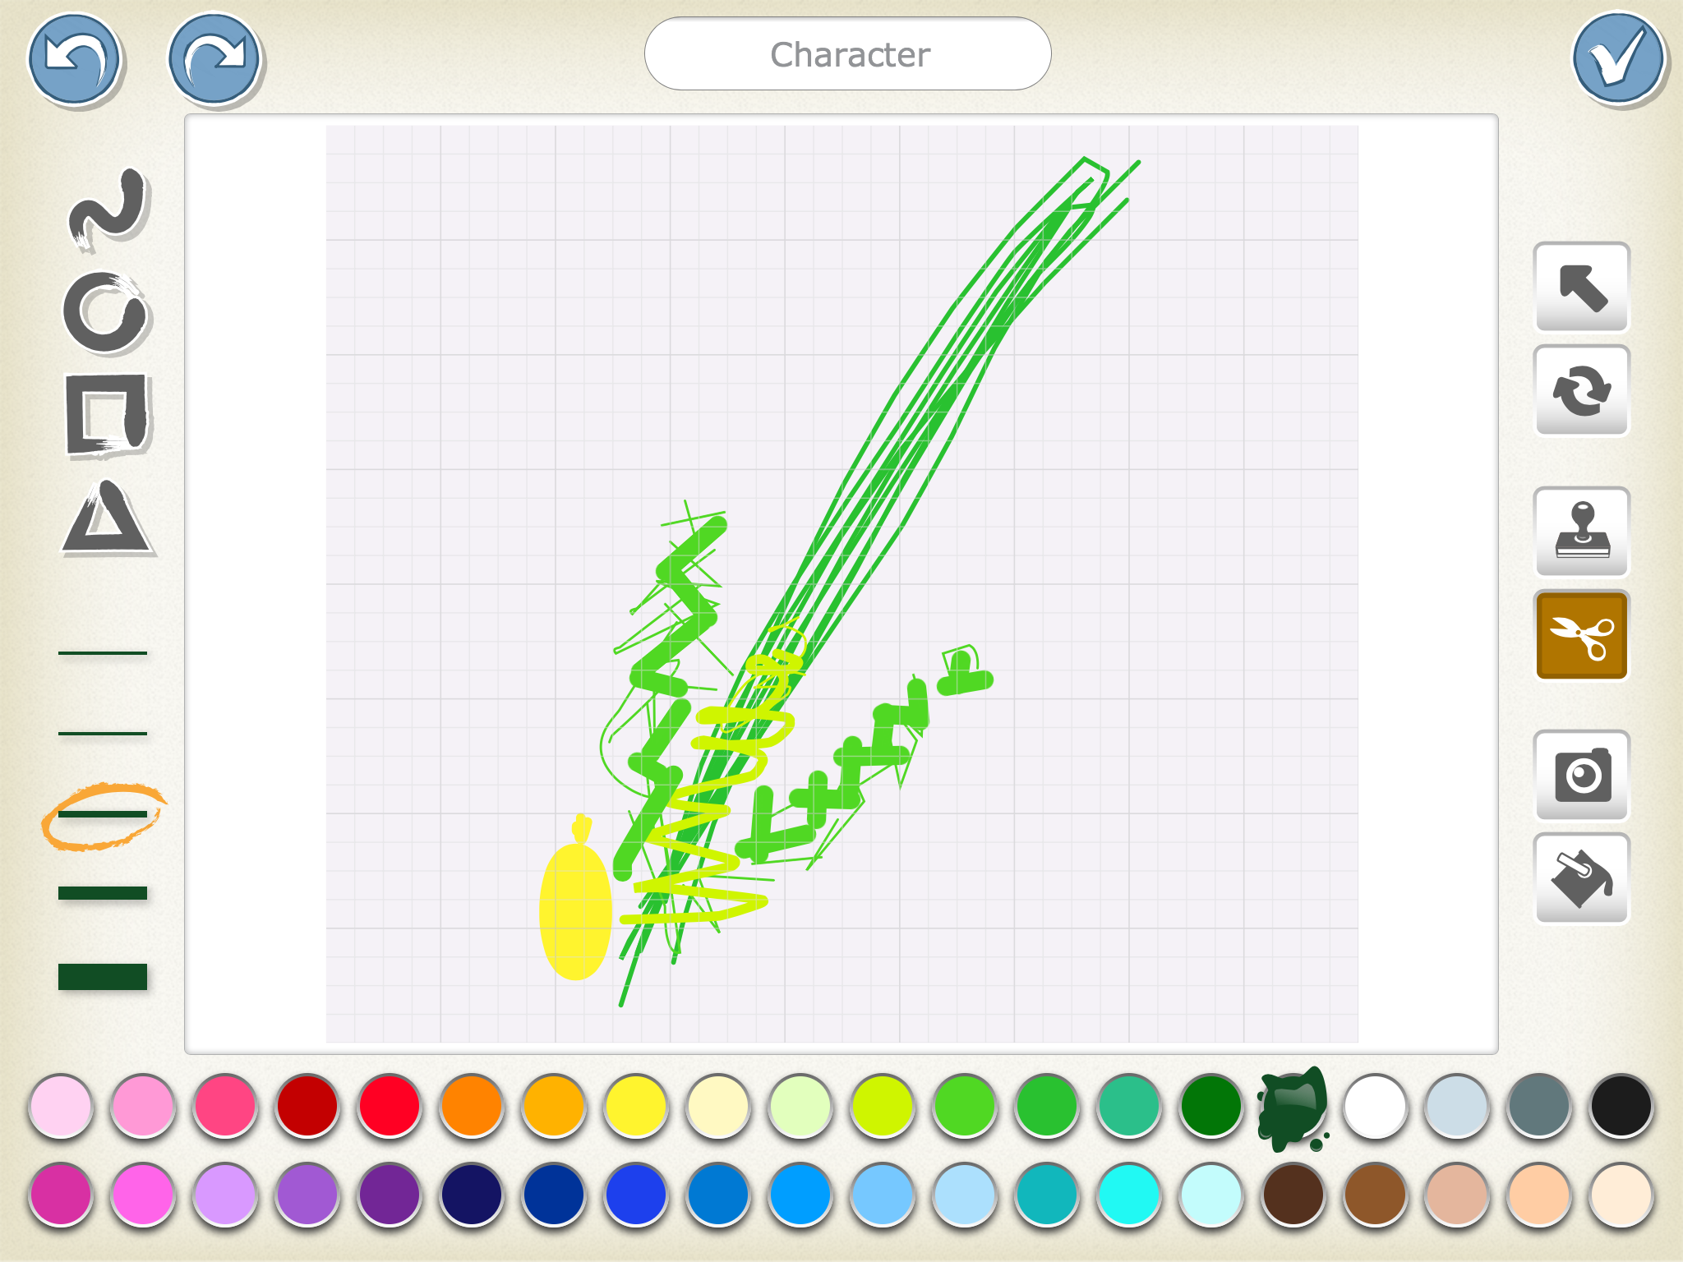

Program the lulav to shake when tapped
Use the ‘Start on Tap’ block so the lulav will start its script when the user taps it.
Select blocks that make it look like the lulav is shaking. One way is to make it move back and forth a few times. For example, with these blocks
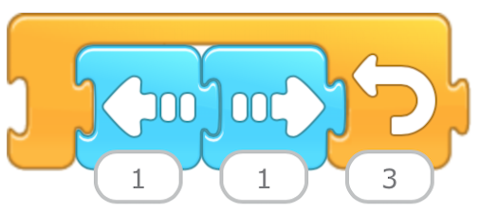
the lulav will move to the left and right, three times. This looks like one shake. To shake in all four directions, use the following code:
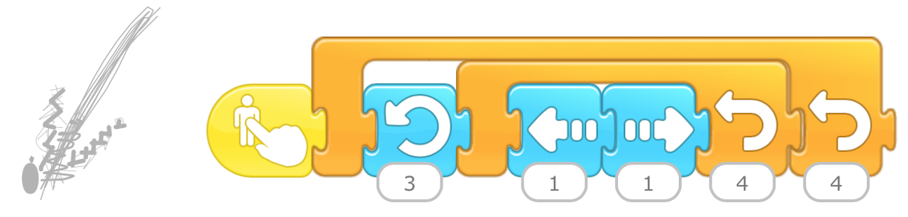
The is an example of embedded repeat functions. The lulav will rotate to the left three steps, then shake back and forth four times. This shaking movement will take place four times, as if the lulav is shaking to the East, West, North and South.
Can you make also shake the lulav Up and Down?

Invite guests to the sukkah
Create a new page.
Draw a sukkah with a door in the Paint Editor.
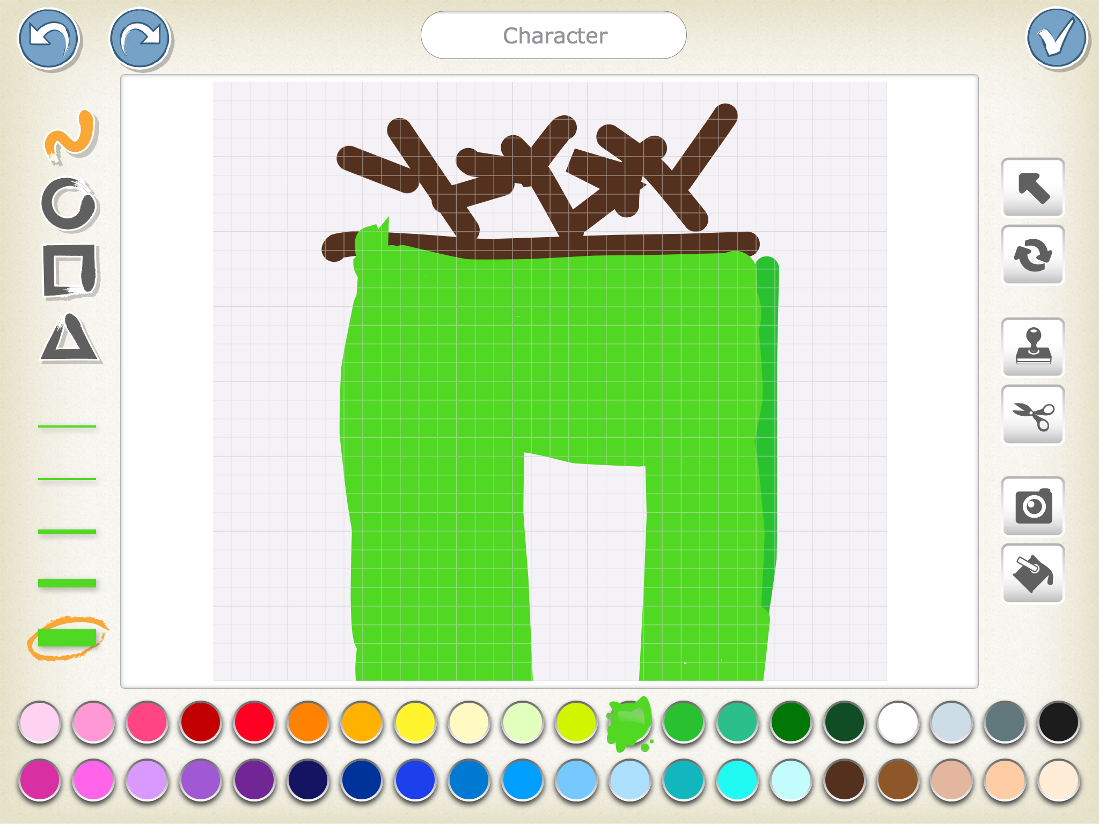
Add three characters for the user to invite to the sukkah and one host.
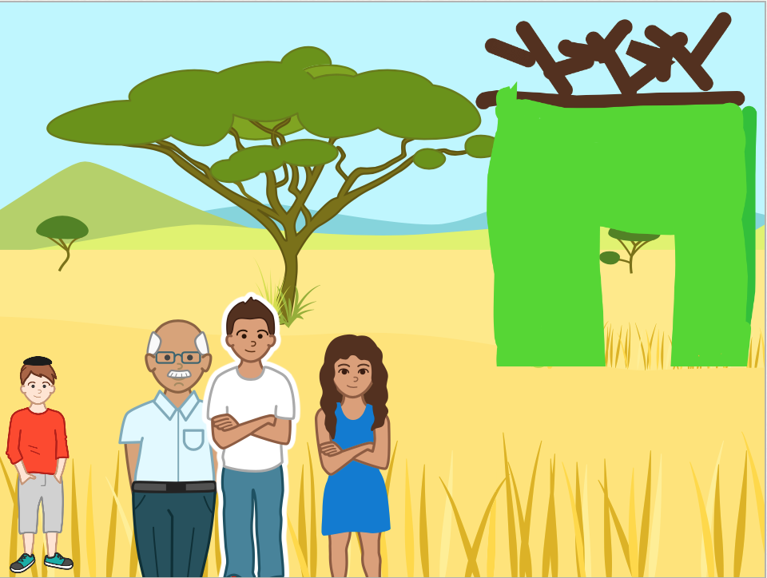
The host character needs to use a Say block to encourage the user to “Tap each character to invite them to the sukkah.”
Each character needs to be programmed to enter the sukkah when tapped. The following blocks will have the character move, shrink, then disappear, as if he or she is walking towards and then into the sukkah. You will have to adjust the numbers on the movement blocks, depending on the dimensions of the sukkah and the starting location of the guests.
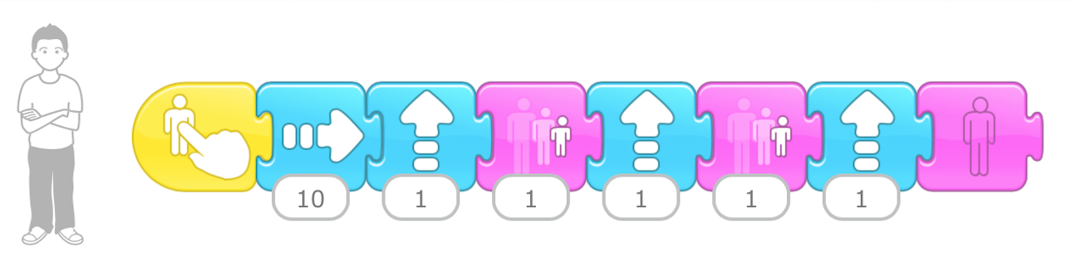

Sleep in the sukkah and see the stars
On a new page, select a nighttime background and add a sukkah.
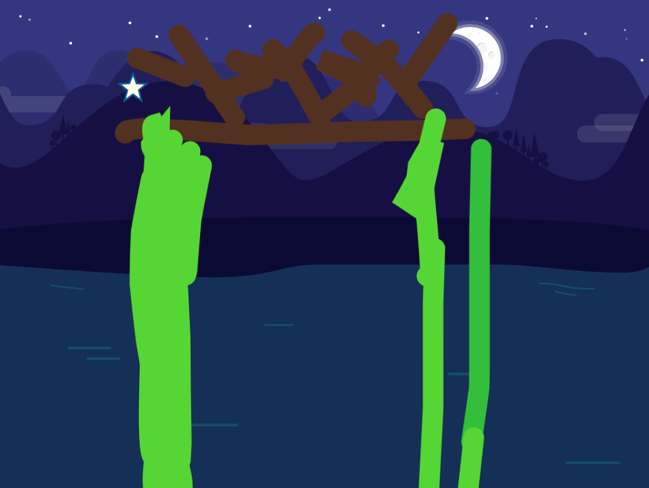
Add many stars in the sky. Use the Stamp in the Paint Editor to create multiple stars in one character.
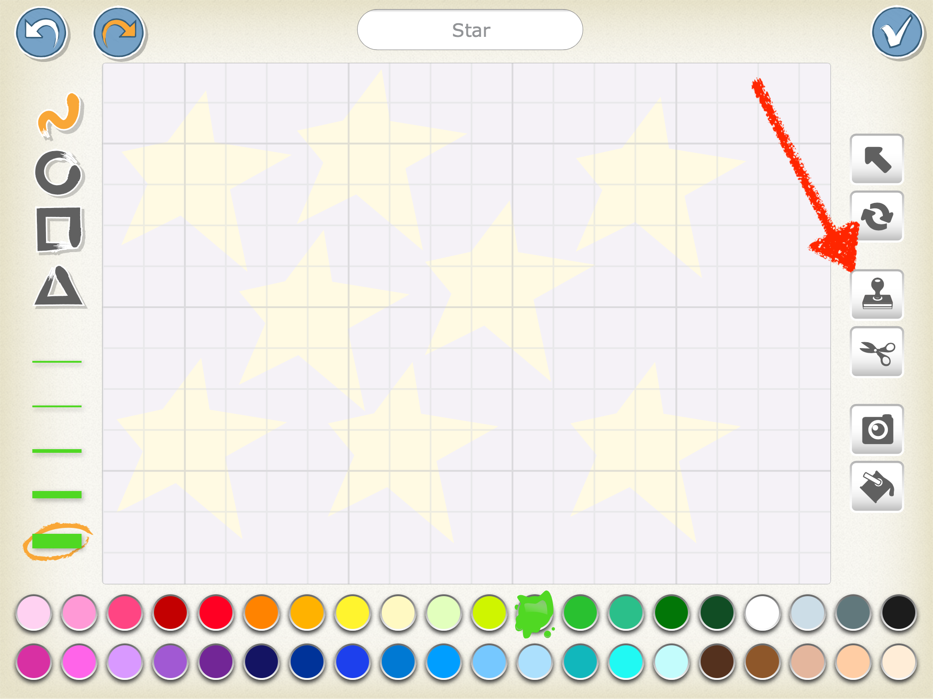
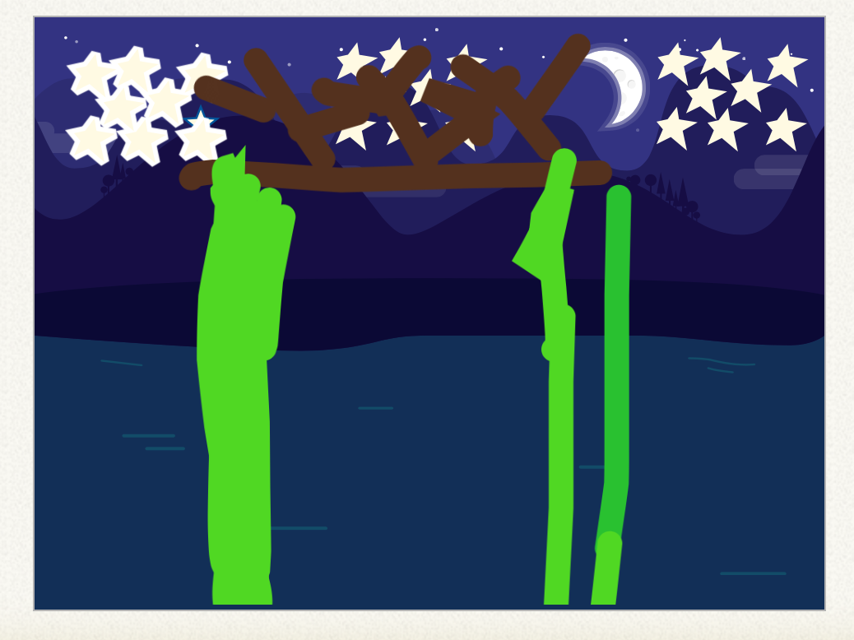
Make the stars ‘twinkle’ by having them appear and disappear.
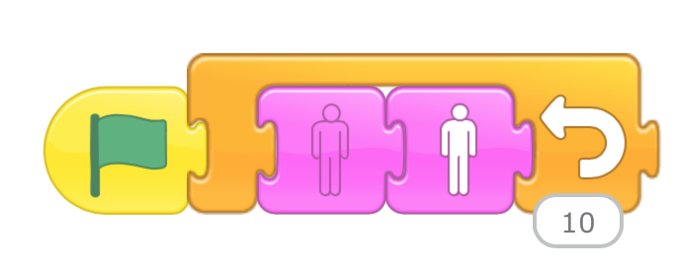

References:
The Official Scratch Jr. Book by Marina Umaschi Bers & Mitchel Resnick
Scratch Jr. website: www.scratchjr.org

